Fact File
Item | Ireland | China
Draw the flag | 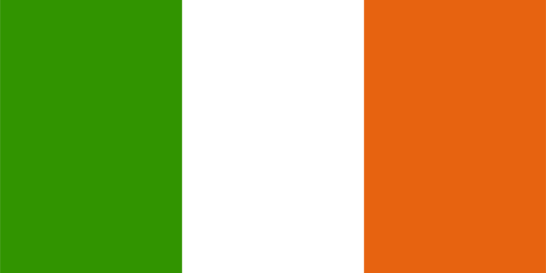 | 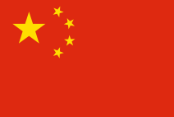
Size | 68,890km² | 9,596,960km²
Continent | Europe | Asia
Capital City | Dublin | Beijing
Provinces | 4 | 23
Main Language | Irish/English | Mandarin
Longest River | Shannon | Yangtze
Highest Mountain | Macgillycuddy's Reeks | Mount Everest
Currency | Euro | Yuan
Main religion(s) | Catholic | Taoism, Buddhism

