Senior Infants Work-Week beginning Monday 25th May
Hi everyone, I hope last week went well for you all and you enjoyed your weekend and had a nice rest. Thank you for the lovely photos, I love to see your photos and you are all doing such a wonderful job and should be very proud of yourselves. Don’t forget to do lots of playing outside after all your hard work, and I hope you are taking lots of movement breaks! I’ve attached this week’s work below, but again, only do what you are able for. Hopefully this week will bring some more lovely sunny days for you to enjoy outdoors, have fun!
Don’t stress about what you don’t get done, but be proud of what you DO get done,
no matter if it is a little or a lot! As always, if you don’t have access to the internet, you can still work on the workbook pages, your non-fiction and fiction readers, and work on lots and lots of practicing of your sight words and sounds. And don’t forget to Read, Read, Read!!! Paired Reading with a parent is a very effective way of increasing reading enjoyment and motivation. Bedtime stories are a fantastic way to incorporate Paired Reading into daily life.
Please pick and choose from the below activities and ONLY DO WHAT SUITS YOUR FAMILY, don’t feel that you have to do everything. Have a good week everyone and as always, any questions or concerns, please ask!
Work for week beginning Monday 25th May
English-Over the Moon Unit 9  - Reader:  - Writing: My News/ Writing on a topic: Choose from Topic Tree at back of Skillsbook  - Writing to Socialise-Story: Fun at the Campsite, Skillsbook page 117  - Reading Comprehension: Dear Greenpeace, Skillsbook page 114  - Phonics/Grammar/Sight Words: Syllables Skillsbook page 113, Segmenting Skillsbook page 116, Revision of Tricky Words.  - Oral Language: Poster 9-The Campsite, Skillsbook page 115  - Aistear: The Airport | Maths  Busy at Maths  Chapter 56-Summer pg. 114  Chapter 57-Capacity pgs. 115, 116, 117, 118  Home School Links book page N/A  Master your Maths-weekly tests | Gaeilge: Abair Liom B, Súil Siar 5, pages 100-101
Handwriting: Choose an activity from the Letter Formation and Writing Activities on the class page on school website, complete the next page in your handwriting workbook. | PE: Choose from the list of ‘PE At Home’ activities on the class page on school website. The ‘Indoor PE and movement breaks’ section also useful. | Fine Motor: Some fine motor skills activities from the list on the class page of school website
Below I have explained how to go about doing the above work with your child. However, this is just a guide, if you wish to go about it a different way, please do. This is just to help anyone who would like it. If you can email on photos by Friday evening I’d really appreciate it, if this is not possible, don’t worry.
Senior Infants Week beginning Monday 18th May
English Literacy: Over the Moon Programme
Unit 09 Theme: Let’s Go Camping!

Oral Language: Poster 9-The Campsite
Access the Oral Language poster here: https://www.gillexplore.ie/gill-explore-resources/over-the-moon-senior-infants-skills-book?Chapters=7662&ResourceTypes=11535

Talk about camping: What is camping? Have you ever been camping? What did you do/see/smell/taste/feel there?

List
Make a list of things you might bring on a camping trip. After you explore the poster, discuss the list. Did you pack the same items as they children in the poster? Would you like to add to your list now? The list could also be rewritten in alphabetical order for an added challenge.

Discussing the scene
Where is this poster set? Who can you see in the poster? What is Ella/Mam/Tom/etc. doing at the campsite? When do you think they went to the campsite? Why do you think there is a flashlight in the tent?

Skills book page 115
Listen to the instructions and complete the picture.
The family are going hiking tomorrow. Mam brought a compass to help them find their way. Find the compass and colour it red.
It is getting dark. Dad put on the lantern to give them some light. Find the lantern and colour it blue.
The family pitched two tents at the campsite. Write the letter ‘b’ on the big tent. Write the letter ‘s’ on the small tent.
Everyone is feeling hungry. Draw some food cooking on the barbecue and draw a sausage on Dad’s fork.
Draw a smiley face on the moon and put a ring around the big cloud.
Mam is about to go looking for more firewood. Put a torch in Mam’s hand and a cap on her head.
Ella spots a hiker on top of the tallest mountain: he looks very small as he is far away. Draw a tiny stickman on the side of the tallest
mountain.
Ella is having dessert before dinner! Put a marshmallow on top of the stick in Ella’s hand.

Reading Comprehension Story from last week: Dear Greenpeace by Simon James. Youtube Read Aloud: https://www.youtube.com/watch?v=Qz6zULKr6kE

Skills book page 114-Complete a report on the blue whale

Genre Story eBook: Fun at the Campsite Writing Genre: Writing to Socialise

The Genre of Writing to Socialise includes social texts such as letters, cards, emails, text messages, lists, forms, postcards, thank you notes, messages, etc.

Access the story ebook here: https://www.gillexplore.ie/gill-explore-resources/over-the-moon-senior-infants-skills-book?Chapters=7662&ResourceTypes=11314

Before reading:
Look at the cover and discuss the theme of camping. Have you ever been camping? What did you see/smell/feel there? Where was it? Hae you ever made a pretend campsite at your home? What did you pretend to do there?

Discuss the title: Do you think the characters are enjoying camping? What clue helped you to make this prediction?

During Reading:
Email | Why do you think Mam sent an email instead of a letter?
Booking Form | Read and point out the features of the form. Discuss: Why is Mam filling this in? Why does the campsite need forms like this?
Mam’s List for Tom | Why did Mam write a list for Tom?
Get Well Card | Point out the greeting, the message and the closing. Discuss who sent the card and the reason why.
Postcard | Point out the greeting, the message and the closing. Discuss who sent the card and the reason why. Talk about the joke and why it was included.

Skills book page 117: Read the words and colour the pictures. Help each character to find a resolution.

My News/Diary: Writing simple personal ‘news’ is useful for helping practice handwriting, basic sight words spelling, and conventions of writing such as sentence structure and grammar. Capital letters and full stops are what we concentrate on in Junior and Senior Infants, as well as sizing of the letters and using ‘finger spaces’ between words.

Topic Writing: Choose a topic from the Topic Tree at back of Skillsbook.
Phonics/Grammar/Sight Words:

Skills book page 113-Syllables
Skills book page 116-Segmenting

Sight Word revision- Tricky Words Week 2:
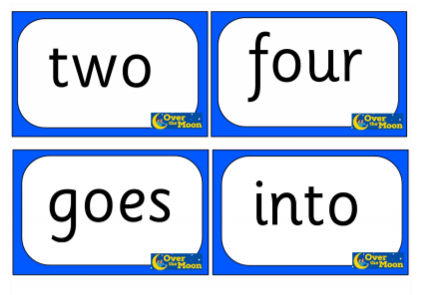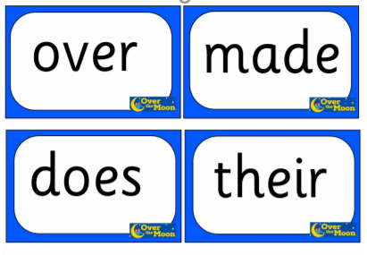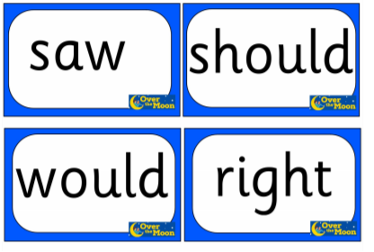

Tips for parents for using the Jolly Phonics programme available on the Jolly Learning website: https://www.jollylearning.co.uk/school-closure-support-for-parents/

It’s very important to keep revising sounds, to practice blending the letters to make words-eg- “c-a-t” says “cat” and practice the sight words and sounds mat which Ms. O’Toole sent home.

Aistear: New Aistear Theme: The Airport
Some of the classroom ideas can be adapted for the home or try out your own ideas. Pinterest also has lots of ideas and printables on Airport Roleplay areas and Twinkl has some lovely Aistear printables here https://www.twinkl.ie/search?term=the+airport+aistear
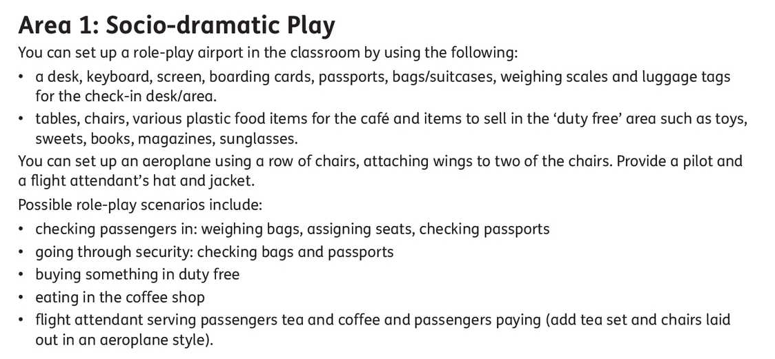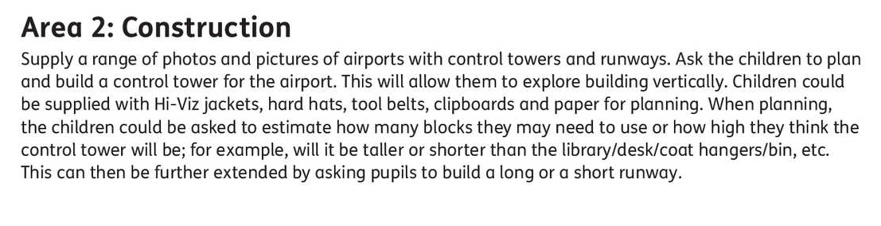
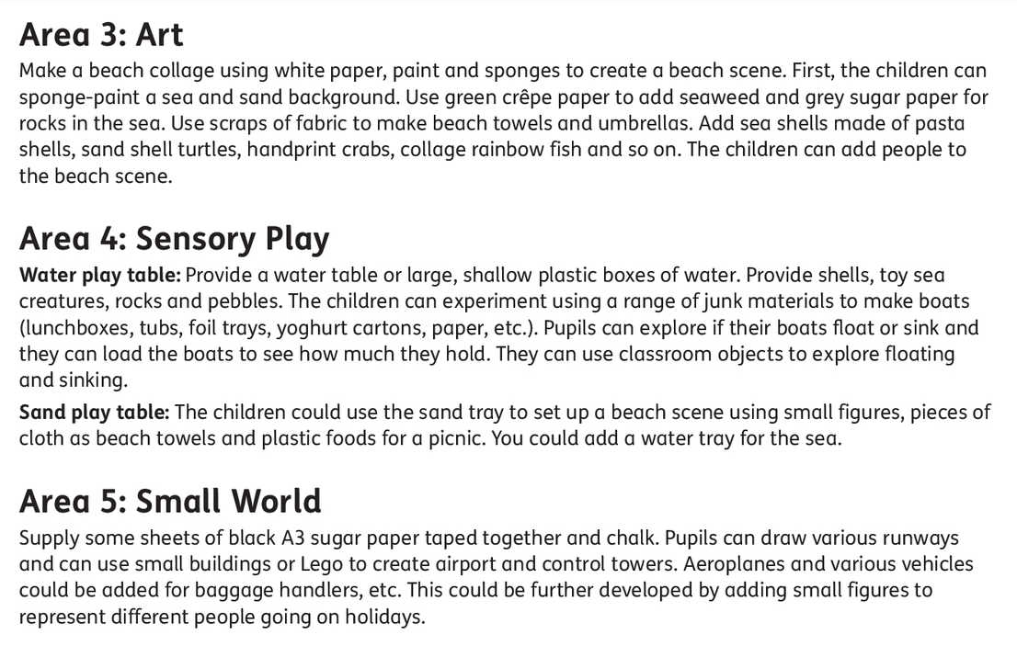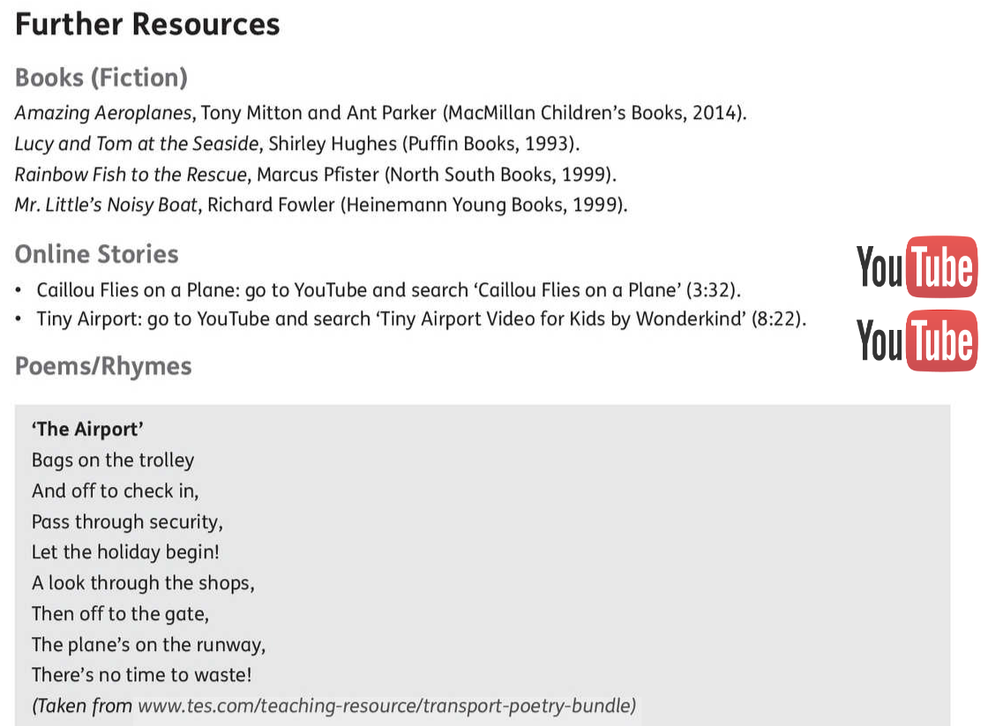
Maths

Summer/Capacity

Busy at Maths materials online at mycjfallon.ie
Busy at Maths Pupils’ Textbook: Pages 114, 115, 116, 117, 118

Home School Links Book: No pages this week.

Master your Maths book: Start new week Mon-Thursday and corresponding end of week Test. Don’t forget to time yourself and record your time each day to see if you are getting faster!

Page 114 : http://data.cjfallon.ie/resources/19602/activity-114/index.html
Page 115: http://data.cjfallon.ie/resources/19602/activity-115/index.html
Page 116: http://data.cjfallon.ie/resources/19602/activity-116/index.html
Page 117: http://data.cjfallon.ie/resources/19602/activity-117/index.html
Page 118: http://data.cjfallon.ie/resources/19602/activity-118/index.html

Mathematical language: Let’s talk, How many?, summer, picture 1/2/3/4, guess, estimate, measure, colour, full, empty, holds more, holds less, most, least, not as much, nearly full/empty, nearly as much.

The Home School Links page for this topic is attached below:
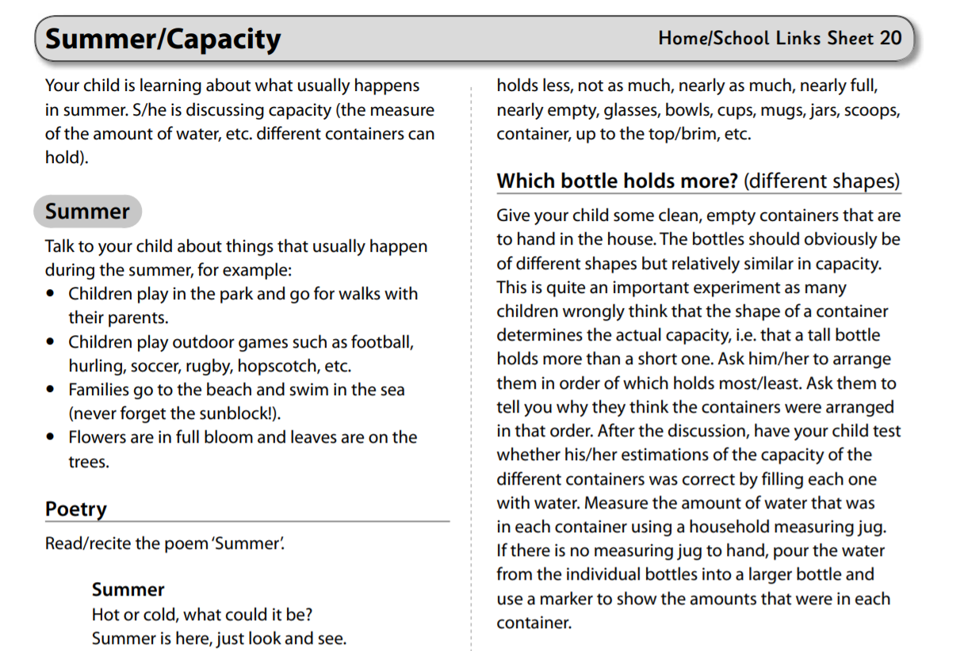
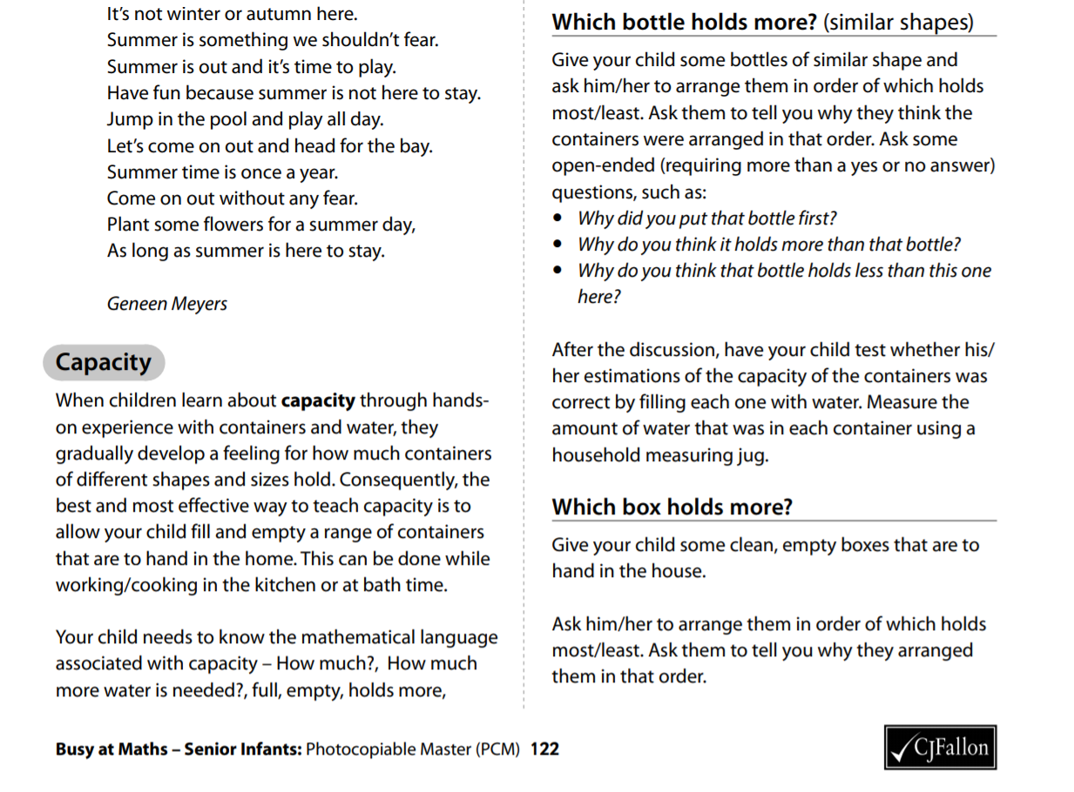
Gaeilge

Súil Siar 5-Looking Back 5
If you don’t feel confident with Gaeilge, don’t worry. There is a free app called DuoLingo which is quite simple and pupils seem to enjoy it. This might be an option. Watching some programmes on TG4 for younger children such as ‘Is Mise’ (https://www.tg4.ie/en/player/online-boxsets/?series=Is%20Mise&genre=Cula4) is another idea to expose children to the language in a fun way. If you do want to attempt it, I’ve translated this week’s story and tasks below. Abair Liom B has some nice songs and rhymes online also.

Aonad 29: Súil Siar 5 (Looking back 5)

Abair Liom B pages 100-101

All resources for the Abair Liom Programme are available free on www.folensonline.ie . To set up an account, follow the steps below:
- Go to Folensonline.ie and click Register
- Select Teacher
- Fill in a username, email and password
- When asked for Roll Number, use the code: Prim20
- Type ‘Abair Liom B’ into search bar.
- Under the image of ‘Abair Liom Senior Infants’, click on ‘Resources’
- Under ‘Lesson’, click on ‘Súil Siar 5’ and you will see all resources for this Unit.

Tip-if you are unsure of the pronunciation of any of the words, www.focloir.ie is an online dictionary and you can click on the speaker icon to hear the word pronounced as Gaeilge.

Abair Liom B pupil’s textbook: Pages 100-101 (Junior Infants will need a good bit of help with this-just try your best)

Put your finger on the bird. Colour the bird brown.
Put your finger on the ice cream. Colour the ice cream purple.
Put your finger on the sandcastle. Colour the sandcastle orange.
Put your finger on the spade. Colour the spade green.
Put your finger on the boat. Colour the boat black.
Put your finger on the horse. Colour the horse brown.
Put your finger on Oisín jumping. Colour Oisín orange.
Put your finger on the lollipop. Colour the lollipop red.
Put your finger on the chocolate. Colour the chocolate brown.
Put your finger on the basketball. Colour the basketball yellow.
Put your finger on the rainbow. Colour the rainbow multicolour.

Cuir méar ar an t-éan. Dathaigh an t-éan donn.

Cuir méar ar an uachtar reoite. Dathaigh an t-uachtar reoite corcra.
Cuir méar ar an gcaisleán gainimh. Dathaigh an gcaisleán gainimh oráiste.

Cuir méar ar an spád. Dathaigh an spád glas.

Cuir méar ar an mbád. Dathaigh an mbád dubh.

Cuir méar ar Oisín ag léim. Dathaigh Oisín oráiste.

Cuir méar ar an líreacán. Dathaigh an líreacan dearg.

Cuir méar ar an tseachláid. Dathaigh an tseachláid donn.
Cuir méar ar an liathróid chispheile. Dathaight an liathróid chispheile buí.

Cuir méar ar an bogha báistí. Dathaigh an bogha báistí ildaite.

Lch 101: B Scríobh an litir cheart.

Page 101: B- Write the correct initial sound.

Textbook page 101: C. Listen and join the dots.
Say: ‘Put your finger on Sean swimming in the sea, now join the dots.
Put your finger on Seán reading book, now join the dots.
Put your fingers on Seán listening to music, now join the dots.
Put your finger on Seán playing basketball, now join the dots.

Put your finger on Seán building a sandcastle, now join the dots.
Put your fingers on Seán running in the garden, now join the dots.

