Task 1
Poetry Prediction
Look at these pictures. What do you think the old lady is doing with the animals?

Poetry Prediction
Look at these pictures. What do you think the old lady is doing with the animals?

Task 2 Learn a poem from memory.
There was an old lady who swallowed a frog
There was an old lady who swallowed a frog
I don’t know why she swallowed the frog
She was in a fog!
So she went for a jog.

There was an old lady who swallowed some dirt
It didn’t hurt to swallow the dirt,
She swallowed the dirt to hide the frog
I don’t know why she swallowed the frog,
She was in a fog!
So she went for a jog.

There was an old lady who swallowed some seeds
At high speeds indeed
She swallowed the seeds to fill in the dirt
She swallowed the dirt to hide the frog
I don’t know why she swallowed the frog
So she went for a jog.

There was an old lady who swallowed the rain
What did she gain by swallowing the rain?
She swallowed the rain to water the seeds.
She swallowed the seeds to fill in the dirt
She swallowed the dirt to hide the frog
I don’t know why she swallowed the frog
She was in a fog.
So she went for a jog.
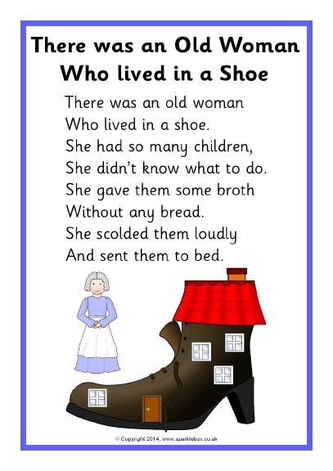
Task 3
Read the poem – there was an old lady that swallowed a frog
- Name three objects the old lady swallowed.
- Write three words you like in the poem.
- What is your favourite line?
- Who is the poem about?
- Why did the old lady swallow some dirt?
- Why did the old lady swallow the rain?
- How do you think jogging helped the old lady?
- Find four different rhyming words in the poem.
- Do you think the old lady needs help?
- What else do you think she might swallow?
- Do you think she will get sick?

