Junior Infants Work-Week beginning Monday 25th May
Hi everyone, I hope last week went well for you all and you enjoyed your weekend and had a nice rest. Thank you for the lovely photos, I love to see your photos and you are all doing such a wonderful job and should be very proud of yourselves. Don’t forget to do lots of playing outside after all your hard work, and I hope you are taking lots of movement breaks! I’ve attached this week’s work below, but again, only do what you are able for. Hopefully this week will bring some more lovely sunny days for you to enjoy outdoors, have fun!
Don’t stress about what you don’t get done, but be proud of what you DO get done,
no matter if it is a little or a lot! As always, if you don’t have access to the internet, you can still work on the workbook pages, your non-fiction and fiction readers, and work on lots and lots of practicing of your sight words and sounds. And don’t forget to Read, Read, Read!!! Paired Reading with a parent is a very effective way of increasing reading enjoyment and motivation. Bedtime stories are a fantastic way to incorporate Paired Reading into daily life.
Please pick and choose from the below activities and ONLY DO WHAT SUITS YOUR FAMILY, don’t feel that you have to do everything. Have a good week everyone and as always, any questions or concerns, please ask!

Work for week beginning Monday 25th May
English-Over the Moon Unit 9 Theme: Holidays  Skills Book pages 106, 107, 108, 109, 110.  Reader: Non-fiction reader-Packing for my Holidays  Reading: Grandad’s Secret Giant Skillsbook page 106  Reading and Writing: Procedural Writing (Story-We’re All Going on a Summer Holiday) Skills book page 110.  Oral Language: Poster 9: The Airport, talk and discussion, questions, Barrier game page 108 in skills book.  Phonics/Grammar/Sight words: Sounds Group 4 Revision, Skills book page 107: Segmenting. Skills book page 109:Phrases. Sight words revision: you, come, some, they, do, here.  Aistear: The Airport | Maths Money  Busy at Maths pages 113, 114, 115, 116  Home school links book page 37 | Gaeilge: Súil Siar 5, Pgs. 100-101
Handwriting: Choose an activity from the Letter Formation and Writing Activities on the class page on school website, complete the next page in your handwriting workbook. | PE: Choose from the list of ‘PE At Home’ activities on the class page on school website. The ‘Indoor PE and movement breaks’ section also useful. | Fine Motor: Some fine motor skills activities from the list on the class page of school website
Below I have explained how to go about doing the above work with your child. However, this is just a guide, if you wish to go about it a different way, please do. This is just a guide to help anyone who would like it. If you can email on photos at the end of the week I’d really appreciate it, if this is not possible, don’t worry.
Junior Infants Week beginning Monday 25th May
English Literacy: Over the Moon Programme
Unit 09 Theme: Holiday
Oral Language:
Poster 9: The Airport

To access interactive activities and oral language poster, go to https://www.gillexplore.ie/gill-explore-resources/over-the-moon-junior-infants-skills-book

Then under All Chapters, scroll down and click Unit 09 and under All Resource Types, scroll down and click Oral Language & Interactive Activities, then Oral Language Poster, then Explore Mode.

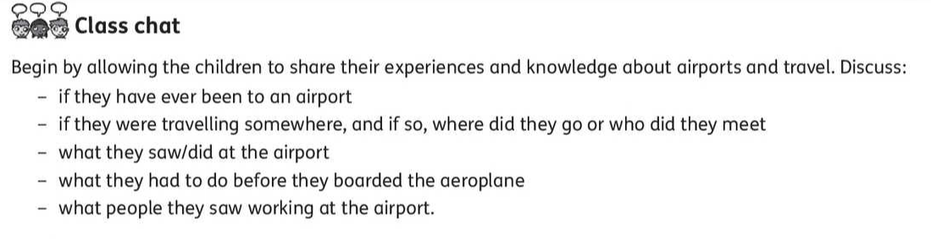
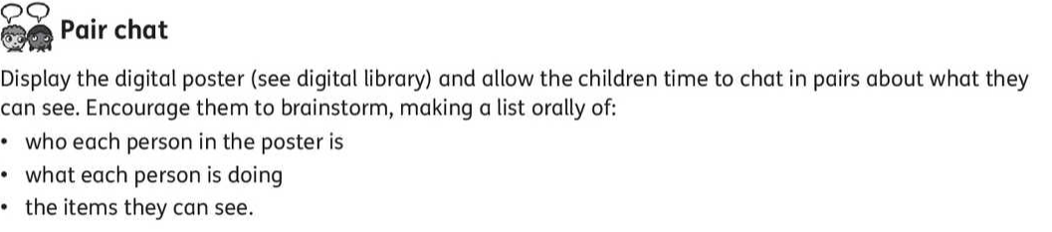

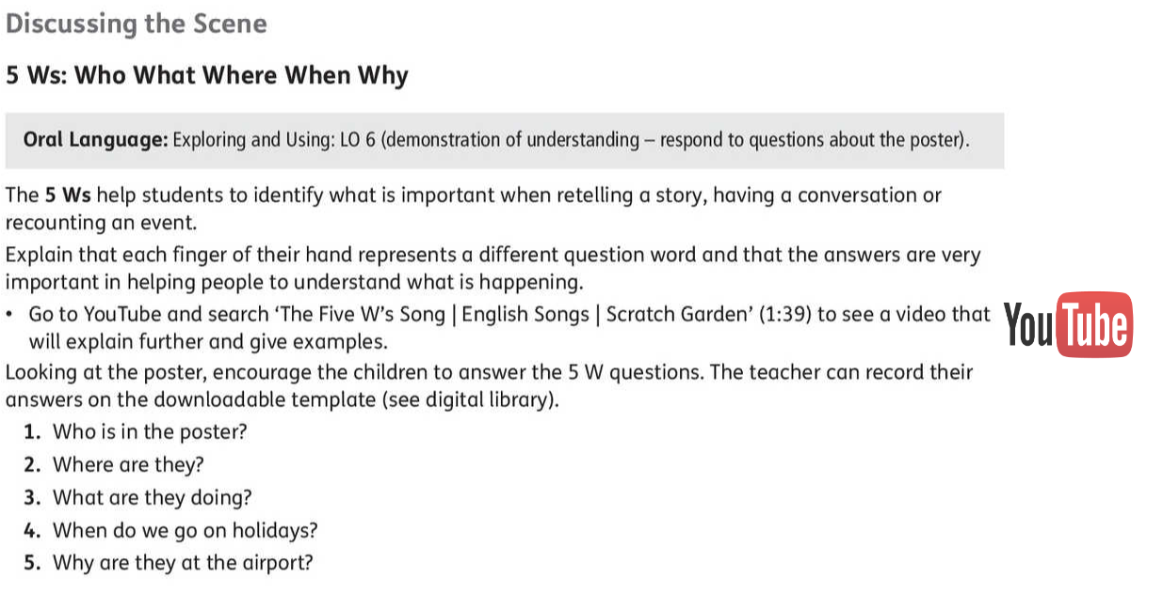

Skills Book page 108:
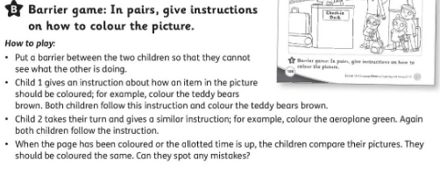

Reading and Writing

Writing Genre: Procedural (How to) Writing
Story: We’re All Going on a Summer Holiday

Introduction to the Procedural Writing Genre: Shared Reading of the Story
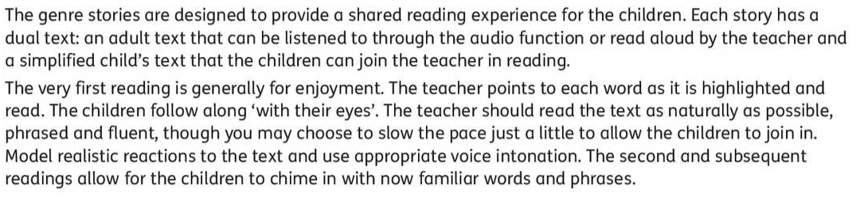

To access the story, go to https://www.gillexplore.ie/gill-explore-resources/over-the-moon-junior-infants-skills-book

Then under All Chapters, scroll down and click Unit 09 and under All Resources, scroll down and click Genre Story eBooks, then the click on the image of the ‘We’re All Going on a Summer Holiday’ book.

Before Reading :

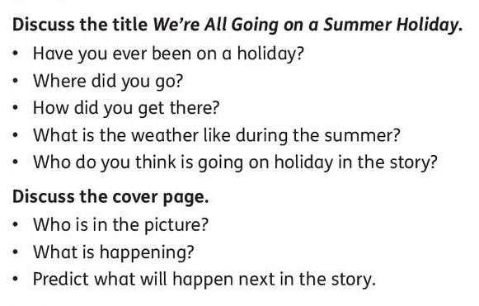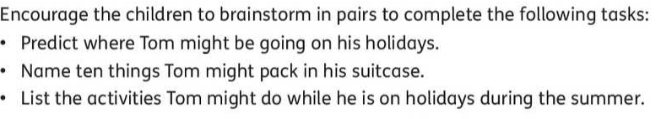
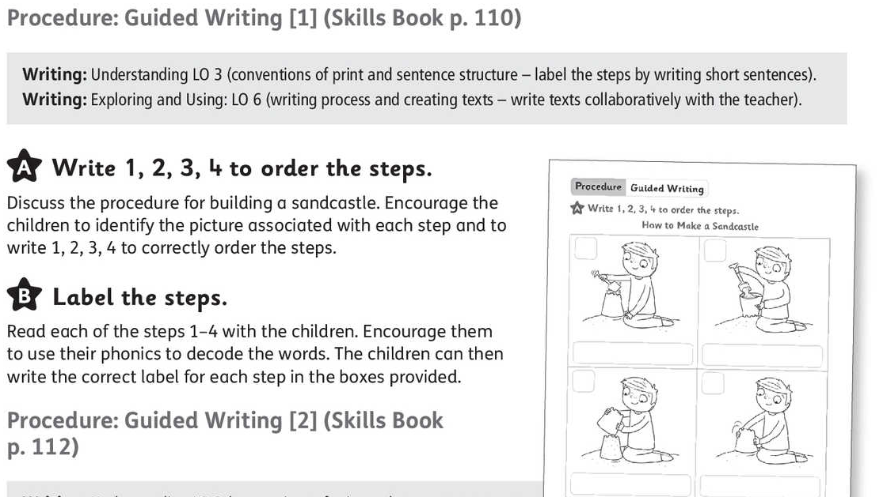

Skills book page 106:
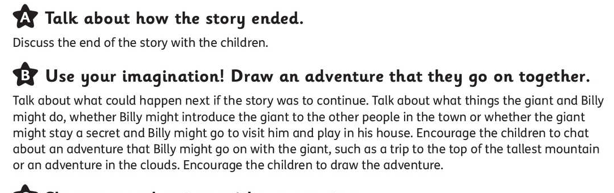
My News/Diary: Writing simple personal ‘news’ is useful for helping practice handwriting, basic sight words spelling, and conventions of writing such as sentence structure and grammar. Capital letters and full stops are what we concentrate on in Junior and Senior Infants, as well as sizing of the letters and using ‘finger spaces’ between words.

Phonics/Grammar/Sight Words:

Skillsbook page 107: Segmenting. Sound out the words and write.
Skillsbook page 109: Tick the correct phrase for each picture-pupil should sound out each phrase and choose the correct one.

Phonics: Revision of sounds, Set 4:
ai j oa ie ee or

The songs for Set 4 sounds can be heard here: https://www.youtube.com/watch?v=iyArsmjYwCs

Here is a reminder of the actions for these sounds:

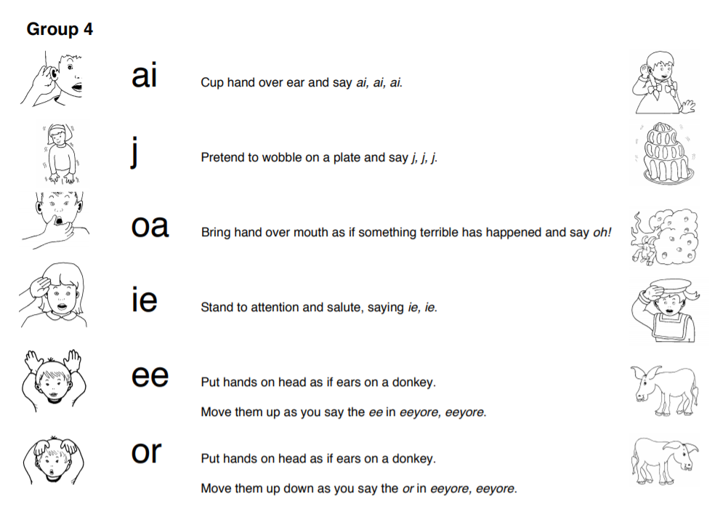
Worksheets on the above sounds at end of this document.

Jolly Phonics sounds revision: https://www.slideshare.net/sockyingseng/jolly-phonics-sounds-and-actions

The Jolly Phonics website has a Homeschool Support page for Parents with some nice ideas and tips as well as a guide to phonics:
https://www.jollylearning.co.uk/school-closure-support-for-parents/

It’s very important to keep revising sounds, to practice blending the letters to make words-eg- “c-a-t” says “cat” and practice the sight words and sounds mat which Ms. O’Toole sent home.
Sight Word Revision Week 3:

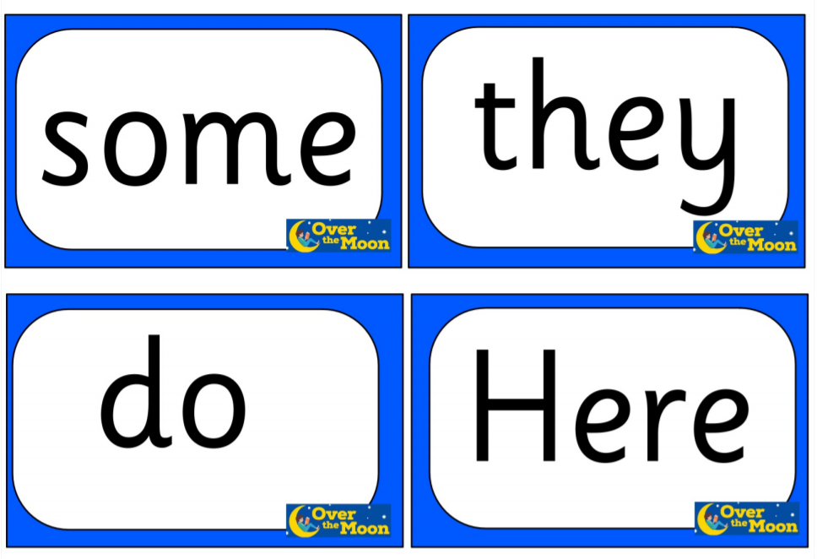

Aistear: New Aistear Theme: The Airport
Some of the classroom ideas can be adapted for the home or try out your own ideas. Pinterest also has lots of ideas and printables on Airport Roleplay areas and Twinkl has some lovely Aistear printables here https://www.twinkl.ie/search?term=the+airport+aistear
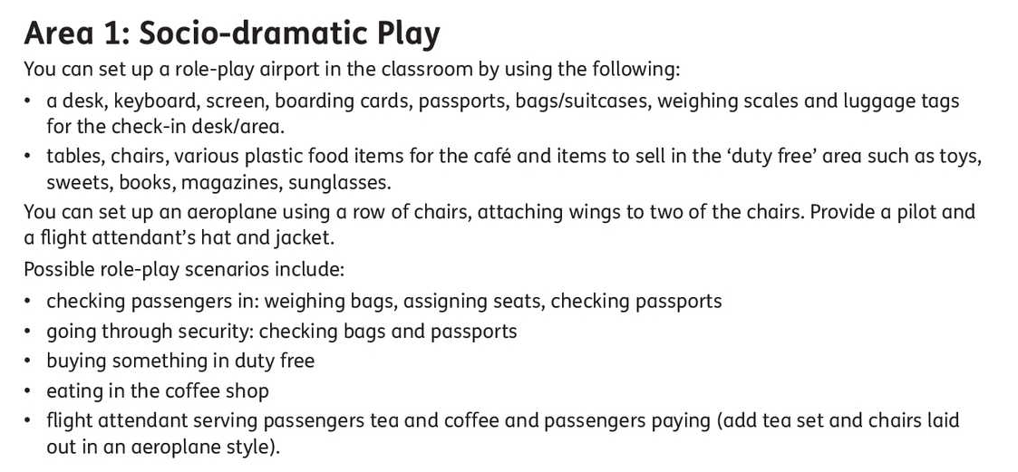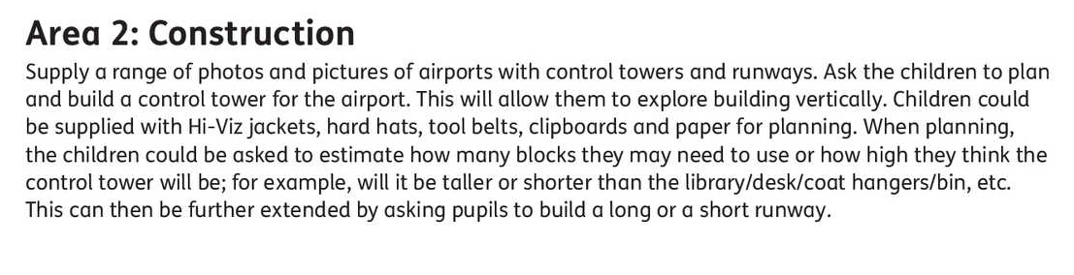
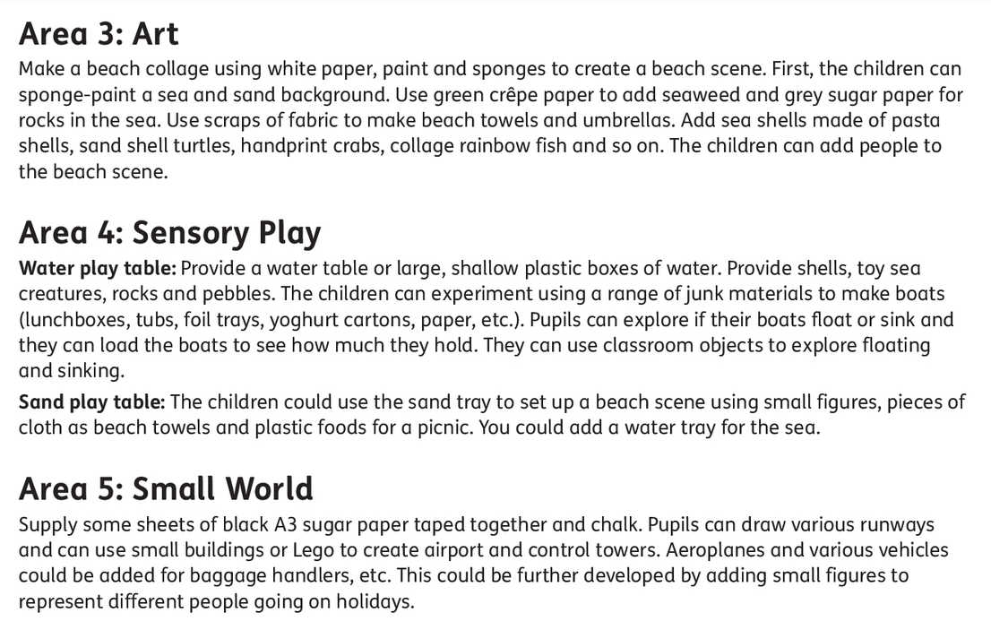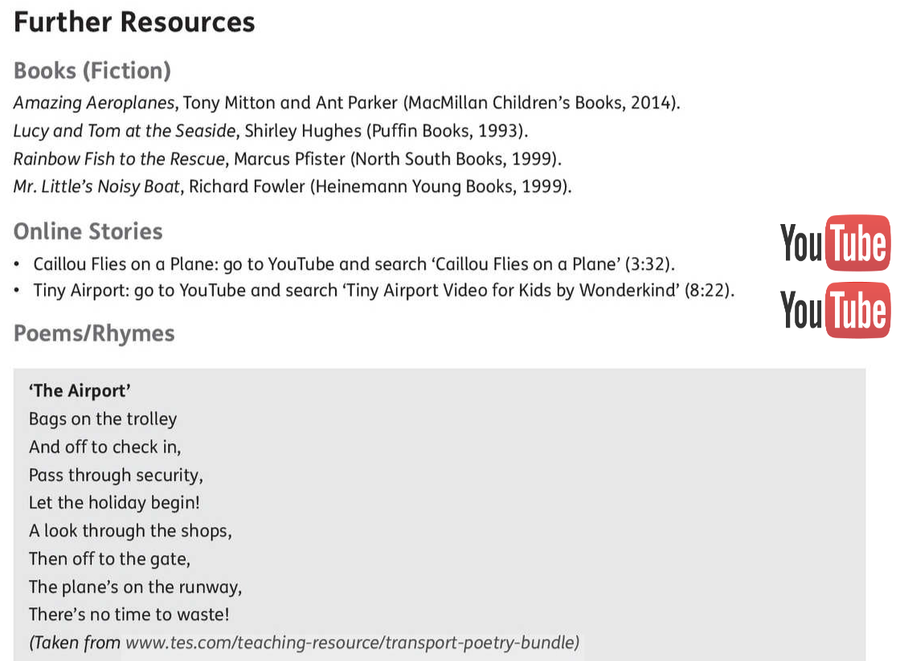
Maths
Chapter 53: Money
Chapter 54: How much?

Busy at Maths materials online at mycjfallon.ie

Busy at Maths Pupils’ Textbook: Pages 113, 114, 115, 116

Home School Links Book: Pages 37

Master your Maths book: Start new week Mon-Thursday and corresponding end of week Test. Don’t forget to time yourself and record your time each day to see if you are getting faster!

Page 113: http://data.cjfallon.ie/resources/19596/activity-113/index.html
Page 114: http://data.cjfallon.ie/resources/19596/activity-114/index.html
Page 115: http://data.cjfallon.ie/resources/19596/activity-115/index.html
Page 116: http://data.cjfallon.ie/resources/19596/activity-116/index.html

Mathematical language: 1c, 2c, 3c, 4c, 5c, coin, how many?, count, what colour?, match, join, brown, copper, buy, cost, price, set, spend, who sells?, more, less, left, box.

The Home School Links page for this topic is attached below:
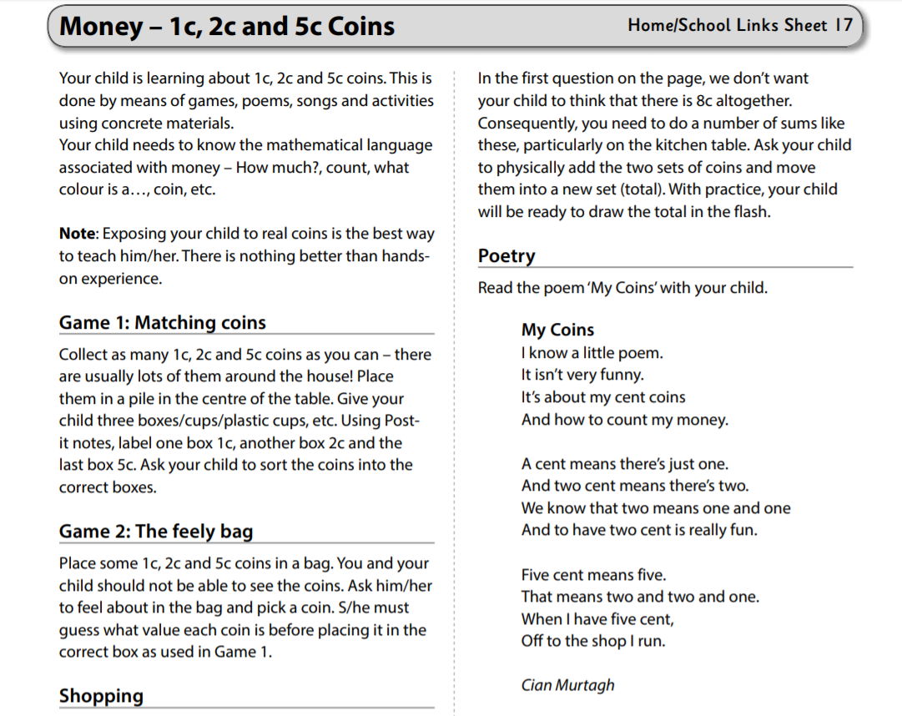
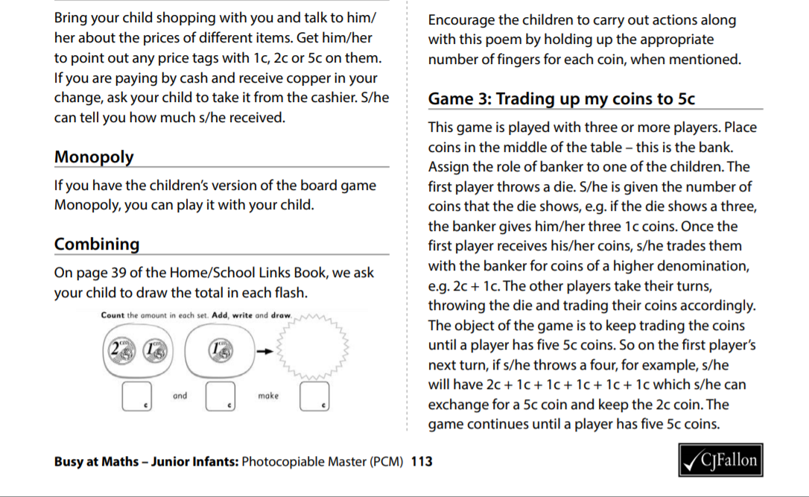
Gaeilge

Súil Siar 5-Looking Back 5
If you don’t feel confident with Gaeilge, don’t worry. There is a free app called DuoLingo which is quite simple and pupils seem to enjoy it. This might be an option. Watching some programmes on TG4 for younger children such as ‘Is Mise’ (https://www.tg4.ie/en/player/online-boxsets/?series=Is%20Mise&genre=Cula4) is another idea to expose children to the language in a fun way. If you do want to attempt it, I’ve translated this week’s story and tasks below. Abair Liom B has some nice songs and rhymes online also.

Aonad 29: Súil Siar 5 (Looking back 5)

Abair Liom B pages 100-101

All resources for the Abair Liom Programme are available free on www.folensonline.ie . To set up an account, follow the steps below:
- Go to Folensonline.ie and click Register
- Select Teacher
- Fill in a username, email and password
- When asked for Roll Number, use the code: Prim20
- Type ‘Abair Liom B’ into search bar.
- Under the image of ‘Abair Liom Senior Infants’, click on ‘Resources’
- Under ‘Lesson’, click on ‘Súil Siar 5’ and you will see all resources for this Unit.

Tip-if you are unsure of the pronunciation of any of the words, www.focloir.ie is an online dictionary and you can click on the speaker icon to hear the word pronounced as Gaeilge.

Abair Liom B pupil’s textbook: Pages 100-101 (Junior Infants will need a good bit of help with this-just try your best)

Put your finger on the bird. Colour the bird brown.
Put your finger on the ice cream. Colour the ice cream purple.
Put your finger on the sandcastle. Colour the sandcastle orange.
Put your finger on the spade. Colour the spade green.
Put your finger on the boat. Colour the boat black.
Put your finger on the horse. Colour the horse brown.
Put your finger on Oisín jumping. Colour Oisín orange.
Put your finger on the lollipop. Colour the lollipop red.
Put your finger on the chocolate. Colour the chocolate brown.
Put your finger on the basketball. Colour the basketball yellow.
Put your finger on the rainbow. Colour the rainbow multicolour.

Cuir méar ar an t-éan. Dathaigh an t-éan donn.

Cuir méar ar an uachtar reoite. Dathaigh an t-uachtar reoite corcra.
Cuir méar ar an gcaisleán gainimh. Dathaigh an gcaisleán gainimh oráiste.

Cuir méar ar an spád. Dathaigh an spád glas.

Cuir méar ar an mbád. Dathaigh an mbád dubh.

Cuir méar ar Oisín ag léim. Dathaigh Oisín oráiste.

Cuir méar ar an líreacán. Dathaigh an líreacan dearg.

Cuir méar ar an tseachláid. Dathaigh an tseachláid donn.
Cuir méar ar an liathróid chispheile. Dathaight an liathróid chispheile buí.

Cuir méar ar an bogha báistí. Dathaigh an bogha báistí ildaite.

Lch 101: B Scríobh an litir cheart.

Page 101: B- Write the correct initial sound.

Textbook page 101: C. Listen and join the dots.
Say: ‘Put your finger on Sean swimming in the sea, now join the dots.
Put your finger on Seán reading book, now join the dots.
Put your fingers on Seán listening to music, now join the dots.
Put your finger on Seán playing basketball, now join the dots.

Put your finger on Seán building a sandcastle, now join the dots.
Put your fingers on Seán running in the garden, now join the dots.

