Junior Infants Work-Week beginning Monday 18th May
Hi everyone, I hope last week went well for you all and you enjoyed your weekend and had a nice rest. Thank you for the lovely photos, I was so delighted to see such amazing work being done, you are all doing a fantastic job and should be very proud of yourselves. Don’t forget to do lots of playing outside after all your hard work, and I hope you are taking lots of movement breaks! I’ve attached this week’s work below, but again, only do what you is achievable for you. Hopefully this week will bring some nice sunny days for playing outdoors, have fun!
don’t stress about what you don’t get done, but be proud of what you DO get done,
no matter if it is a little or a lot! As always, if you don’t have access to the internet, you can still work on the workbook pages, your non-fiction and fiction readers, and work on lots and lots of practicing of your sight words and sounds. And don’t forget to Read, Read, Read!!! Paired Reading with a parent is a very effective way of increasing reading enjoyment and motivation. Bedtime stories are a fantastic way to incorporate Paired Reading into daily life.
Please pick and choose from the below activities and ONLY DO WHAT SUITS YOUR FAMILY, don’t feel that you have to do everything. Have a good week everyone and as always, any questions or concerns, please ask!
Work for week beginning Monday 18th May
English-Over the Moon Unit 8  Reader: Cat Rescue! continued.  Reading Comprehension: Grandad’s Secret Giant, Skillsbook pg. 104 & 106  Oral Language: Game-What Am I?  Phonics/Grammar/Sight words: Sounds Group 3 Revision, sight words revision: he, be, are, all, you, your  Aistear: The Zoo | Maths-Day and Night  Busy at Maths pgs. 108+109  Home school links book page35 | Gaeilge: Abair Liom B, Ar an Trá, Pgs. 96-99
Handwriting: Choose an activity from the Letter Formation and Writing Activities on the class page on school website, complete the next page in your handwriting workbook. | PE: Choose from the list of ‘PE At Home’ activities on the class page on school website. The ‘Indoor PE and movement breaks’ section also useful. | Fine Motor: Some fine motor skills activities from the list on the class page of school website
Below I have explained how to go about doing the above work with your child. However, this is just a guide, if you wish to go about it a different way, please do. This is just to help anyone who would like it. If you can email on photos by Friday evening I’d really appreciate it, if this is not possible, don’t worry.
Senior Infants Week beginning Monday 18th May
English Literacy: Over the Moon Programme
Unit 08 Theme: Emergency Services
Oral Language:
Game: What Am I?
Ask the children the following questions and see how many they can figure out. Then get them to try to come up with their own questions (The questioning can be very difficult for some children so don’t worry if they find this part too hard. )
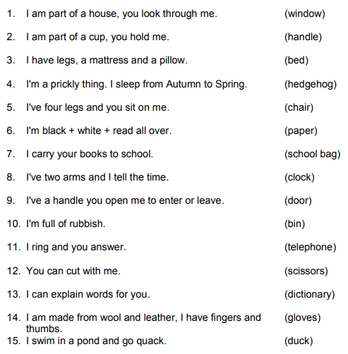
Storytime-Reading Comprehension
Grandad’s Secret Giant

This book is used for this month’s Comprehension strategy-Visualisation.

Some of you may have this picture book at home already. If not, there are many read-aloud videos on youtube of it, for example https://www.youtube.com/watch?v=yPy9UjarCAQ

If you wish to do page 104 and 106 in the Skillsbook you can do them with this story.

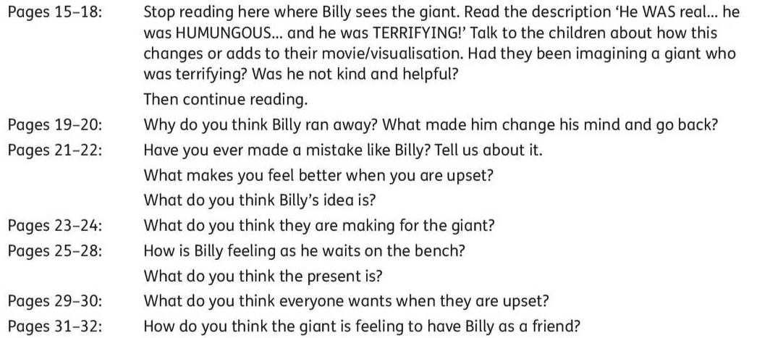
Writing
My News/Diary: Writing simple personal ‘news’ is useful for helping practice handwriting, basic sight words spelling, and conventions of writing such as sentence structure and grammar. Capital letters and full stops are what we concentrate on in Junior and Senior Infants, as well as sizing of the letters and using ‘finger spaces’ between words.
Phonics/Grammar/Sight Words:
Phonics: Revision of sounds, Group 3:
g o u l f b

Worksheets on the above sounds at end of this document.

Jolly Phonics sounds revision: https://www.slideshare.net/sockyingseng/jolly-phonics-sounds-and-actions

The Jolly Phonics website has a Homeschool Support page for Parents with some nice ideas and tips as well as a guide to phonics:
https://www.jollylearning.co.uk/school-closure-support-for-parents/

It’s very important to keep revising sounds, to practice blending the letters to make words-eg- “c-a-t” says “cat” and practice the sight words and sounds mat which Ms. O’Toole sent home.
Sight Word Revision Week 3:
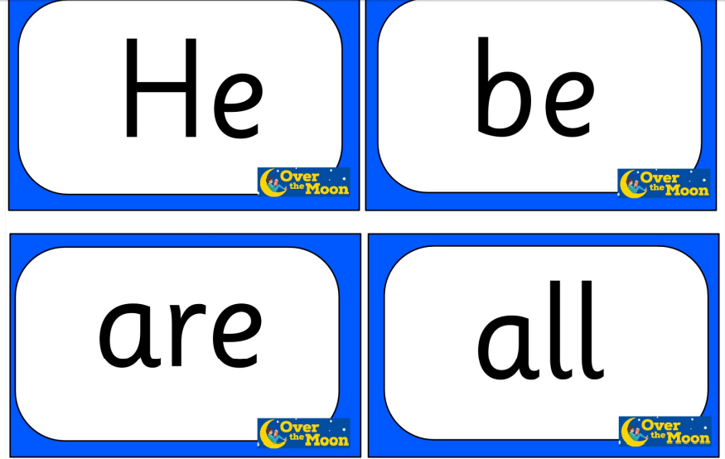

Aistear: Same as last week (The Zoo)
Maths

Day and Night

Busy at Maths materials online at mycjfallon.ie

Busy at Maths Pupils’ Textbook: Pages 110, 111, 112

Home School Links Book: Pages 36

Master your Maths book: Start new week Mon-Thursday and corresponding end of week Test. Don’t forget to time yourself and record your time each day to see if you are getting faster!

Page 110 http://data.cjfallon.ie/resources/19596/activity-110/index.html
Page 111 http://data.cjfallon.ie/resources/19596/activity-111/index.html
Page 112 http://data.cjfallon.ie/resources/19596/activity-112/index.html
Mathematical language: colour, day, night, talk, morning, breakfast, lunch, afternoon, evening, bedtime, count, in, on, under, over, beside, in, near.

The Home School Links page for this topic is attached below:

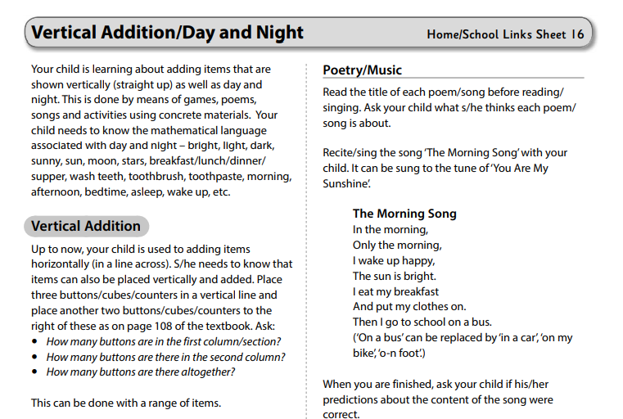
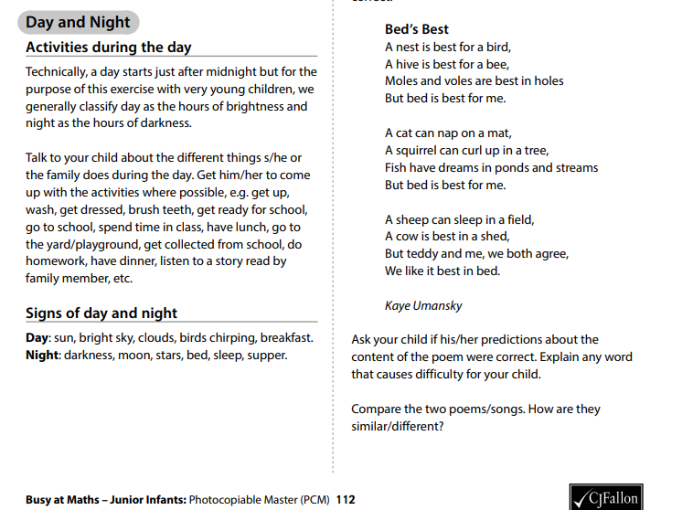

Gaeilge
If you don’t feel confident with Gaeilge, don’t worry. There is a free app called DuoLingo which is quite simple and pupils seem to enjoy it. This might be an option. Watching some programmes on TG4 for younger children such as ‘Is Mise’ (https://www.tg4.ie/en/player/online-boxsets/?series=Is%20Mise&genre=Cula4) is another idea to expose children to the language in a fun way. If you do want to attempt it, I’ve translated this week’s story and tasks below. Abair Liom B has some nice songs and rhymes online also.

Aonad 28-Ar an Trá (On the Beach) Téama: An Aimsir (The weather)

Abair Liom B

All resources for the Abair Liom Programme are available free on www.folensonline.ie . To set up an account, follow the steps below:
- Go to Folensonline.ie and click Register
- Select Teacher
- Fill in a username, email and password
- When asked for Roll Number, use the code: Prim20
- Type ‘Abair Liom B’ into search bar.
- Under the image of ‘Abair Liom Senior Infants’, click on ‘Resources’
- Under ‘Lesson’, click on ‘Ar an Trá’ and you will see all resources for this Unit.

Tip-if you are unsure of the pronunciation of any of the words, www.focloir.ie is an online dictionary and you can click on the speaker icon to hear the word pronounced as Gaeilge.

Abair Liom B pupil’s textbook: Pages 96-99 (Junior Infants will need a good bit of help with this-just try your best)

Textbook page 98. Listen and join the dots.
Say: ‘Put your finger on the bucket, now join the dots. Put your finger on the boat/on the towel/on the sun/on the spade/on the sandcastle/on the cloud. Now join the dots. Colour the picture.
Textbook page 98. Listen and join the dots.
Say ‘Mammy is reading. Join Mammy and the correct picture.
Daddy is listening to music. Join Daddy to the correct picture.
Seán is building a sandcastle. Join Seán and the correct picture.
Oisín is eating. Join Oisín to the correct picture.
Pairwork: Conversation. Textbook, pages 96-97
Get the children to practice making conversation using ‘clothes’ words:
‘I am cold. Put on your ___.’ Then ask the children to practice the conversation in pairs. Do the same thing with ‘I am hot. Take off your ___.’

Acmhainní eile:

https://content.folensonline.ie/programmes/AbairLiom/SI/resources/Dialogue/AL_SI_ACT_Comhra_L28_002/index.html

https://content.folensonline.ie/programmes/AbairLiom/SI/resources/Poster/AL_SI_ACT_Postaer_L28_001/index.html

https://content.folensonline.ie/programmes/AbairLiom/SI/resources/Vocabulary_games/AL_SI_GAME_Flashcard_L28_003/index.html

