Junior Infants Work-Week beginning Monday 11th May
Hi everyone, I hope last week went well and hope you all had a lovely weekend. As always, thank you all for the lovely photographs this weekend, again you have outdone yourselves with all the fantastic work being done! I’m very impressed by all the lovely zoos you have created for Aistear, they look like great fun! Your feedback will be emailed on Monday. Don’t forget to take plenty of breaks and play outside lots, if the weather allows! I’ve attached this week’s work below, but again, only do what you are able for and don’t stress about what you don’t get done.
As always, if you don’t have access to the internet, you can still work on the workbook pages, your non-fiction and fiction readers, and work on lots and lots of practicing of your sight words and sounds. And don’t forget to Read, Read, Read!!! Paired Reading with a parent is a very effective way at increasing reading enjoyment and motivation. Bedtime stories are a fantastic way to incorporate Paired Reading into daily life.
Please pick and choose from the below activities and ONLY DO WHAT SUITS YOUR FAMILY, don’t feel that you have to do everything. Have a good week everyone and as always, any questions or concerns, please ask!
Work for week beginning Monday 11th May
English-Over the Moon Unit 8  Reader: Cat Rescue!  Writing: Independent Writing: Narrative-Problem and Resolution-Skills book pg 100, My News  Poem: Green Giant, Skills Book page 102  Oral Language: Game-10 Questions  Phonics/Grammar/Sight words: Sounds Group 2 Revision, Skills Book page 101, sight words revision: we, me, said, to  Aistear: The Zoo | Maths-Vertical Addition  Busy at Maths pgs. 108+109  Home school links book page35 | Gaeilge: Abair Liom B, Turas scoile go dtí an bhfeirm, pages 92-95
Handwriting: Choose an activity from the Letter Formation and Writing Activities on the class page on school website, complete the next page in your handwriting workbook. | PE: Choose from the list of ‘PE At Home’ activities on the class page on school website. The ‘Indoor PE and movement breaks’ section also useful. | Fine Motor: Some fine motor skills activities from the list on the class page of school website
Below I have explained how to go about doing the above work with your child. However, this is just a guide, if you wish to go about it a different way, please do. This is just to help anyone who would like it. If you can email on photos at the end of the week, I’d really appreciate it. If this is not possible, don’t worry.

Junior Infants Week beginning Monday 11th May
English Literacy: Over the Moon Programme
Unit 08 Theme: Emergency Services

Oral Language:  - Game: 10 Questions  Adult chooses an object from the Oral Language poster (Skillsbook page 96) The child has 10 questions that they can ask in order to guess the ojbect. Encourage them to use their categorising skills to deduce what it is (eg, Is it a food? Is it a person? Is it something you wear?)  - So much of the Junior and Senior Infants Curriculum is based on oral language, so also keep up plenty of chatting and look for new words and vocabulary. | Reading:  Fiction Reader: Cat Rescue!  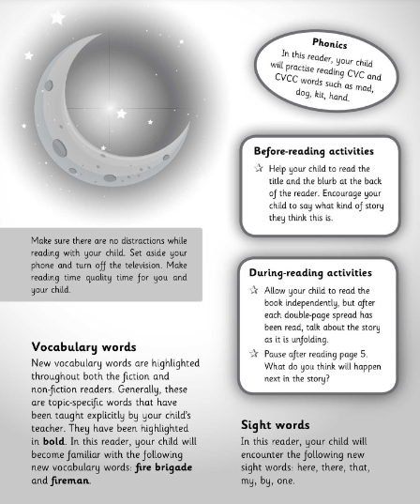  An ebook of the reader is available here:  https://content.yudu.com/web/1yssw/0A224cw/OTMJnrInfsFReader8/html/index.html?refUrl=https%253A%252F%252Fwww.gillexplore.ie%252Fgill-explore-resources%252Fover-the-moon-junior-infants-skills-book%253FChapters%253D7661%2526ResourceTypes%253D11302  Sequencing: Using the sequencing cards (at end of this document), child can cut out and glue the events from the story in the correct order.  If you are still reading ‘Emergency Services’, that is fine, just keep going at child’s own pace.
Reading/Writing:  Genre Story: Who Will Save the Day?  Narrative genre.  Back to the story ‘Who Will Save the Day?’  Problem and Resolution  Skills Book page 100  Discuss each problem with the child. Encourage child to match the problems on the left with the solutions on the right. You can challenge them to come up with an alternative resolution for each problem.  My News/Diary: Writing simple personal ‘news’ is useful for helping practice handwriting, basic sight words spelling, and conventions of writing such as sentence structure and grammar. Capital letters and full stops are what we concentrate on in Junior and Senior Infants, as well as sizing of the letters and using ‘finger spaces’ between words. | Poetry  Back to our poem The Green Giant  ‘Green Giant’  There lived a green giant whose name was Sam.  His hair was the colour of strawberry jam.  He had one brown and one blue eye.  And a beard the colour of pumpkin pie.  His coat and pants were oh so bright,  Like a peppermint stick all red and white.  His socks were as yellow as lemon pop.  His shoes were as brown as a chocolate drop.  His hat was the colour of gingerbread,  With a tall, tall feather of raspberry red.  Skills Book page 102: Listen to the poem and visualise and colour the giant. What foods are in the poem? Draw them around the giant.  Visualising:  Close your eyes while listening to the poem and think about what pictures you see in your head as you listen. Talk about what you are picturing.
Phonics/Grammar/Sight Words:

Phonics: Revision of sounds, Group 2:

n c/k e h r m d

Play ‘Roll a Sound’- printable at end of document
Match initial sounds pictures - printable at end of document

Lots of ideas for the letters here, great if your child is having difficulty with any sounds in particular:
https://www.pinterest.ie/mrkeechsclassroom/jolly-phonics-group-2-activities-worksheets-and-pr/

It’s very important to keep revising sounds, to practice blending the letters to make words-eg- “c-a-t” says “cat” and practice the sight words and sounds mat which Ms. O’Toole sent home.
Sight Words Revision Week 2:
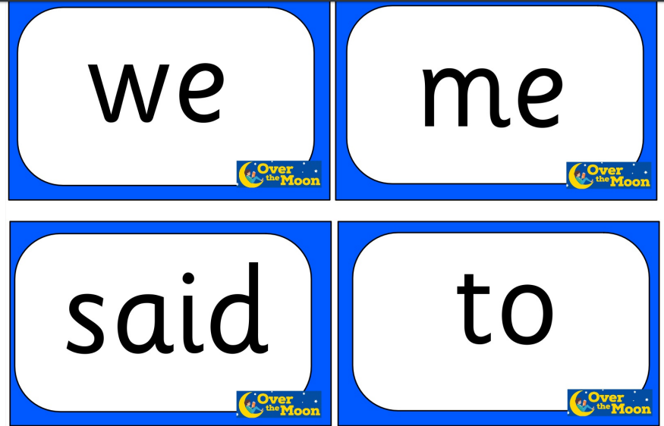
Aistear: Same as last week (The Zoo)
Maths
Vertical Addition

Busy at Maths materials online at mycjfallon.ie

Busy at Maths Pupils’ Textbook: Pages 108 and 109

Home School Links Book: Pages 35

Master your Maths book: Start new week Mon-Thursday and corresponding end of week Test. Don’t forget to time yourself and record your time each day to see if you are getting faster!

Page 108 http://data.cjfallon.ie/resources/19596/activity-108/index.html
Page 109 http://data.cjfallon.ie/resources/19596/activity-109/index.html

Mathematical language: Count, one, two, three, four, five, zero, combine, join, add, how many? more, less, row, set, bigger than, less than, fewer, not as many.

The Home School Links page for this topic is attached below:
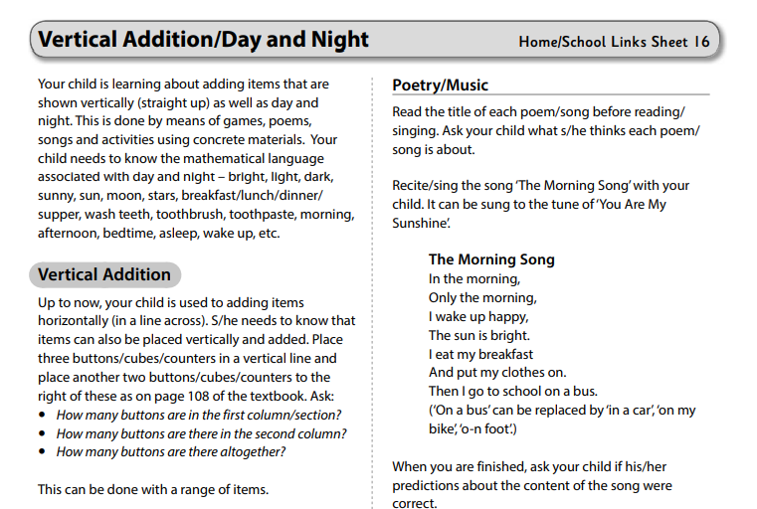

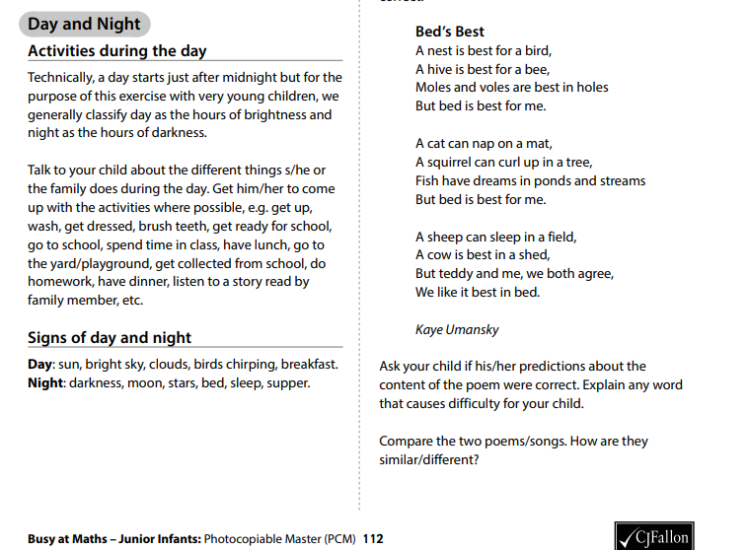

Gaeilge
If you don’t feel confident with Gaeilge, don’t worry. There is a free app called DuoLingo which is quite simple and pupils seem to enjoy it. This might be an option. Watching some programmes on TG4 for younger children such as ‘Is Mise’ (https://www.tg4.ie/en/player/online-boxsets/?series=Is%20Mise&genre=Cula4) is another idea to expose children to the language in a fun way. If you do want to attempt it, I’ve translated this week’s story and tasks below. Abair Liom B has some nice songs and rhymes online also.

Aonad 27-Turas scoile go dtí an bhfeirm (School Trip to the Farm) Téama: An scoil (Theme: School)

Abair Liom B

All resources for the Abair Liom Programme are available free on www.folensonline.ie . To set up an account, follow the steps below:
- Go to Folensonline.ie and click Register
- Select Teacher
- Fill in a username, email and password
- When asked for Roll Number, use the code: Prim20
- Type ‘Abair Liom B’ into search bar.
- Under the image of ‘Abair Liom Senior Infants’, click on ‘Resources’
- Under ‘Lesson’, click on ‘Turas scoile go dtí an bhfeirm’ and you will see all resources for this Unit.

Tip-if you are unsure of the pronunciation of any of the words, www.focloir.ie is an online dictionary and you can click on the speaker icon to hear the word pronounced as Gaeilge.

Abair Liom B pupil’s textbook: Pages 92-95 (Junior Infants will need a good bit of help with this-just try your best)

Textbook page 94. Listen and match together.
Say: Match the big cow and the little cow.
Match the big pig and the little pig.
Match the big horse and the little horse.
Match the big sheep and the little shep.
Match the big bird and the little bird.
Match the big chicken and the little chicken.
Textbook page 95. Circle or square
Say: Draw a circle around the bus.
Draw a square around the children.
Draw a circle around the farm.
Draw a square around the bird.
Draw a circle around the pig.
Textbook page 95. Listen to the sounds and write.
The following lesson is a listening lesson where the children listen to the animal sounds, available online at https://www.folensonline.ie/home/library/programmes/abair-liom-senior-infants/resources/
Say: ‘1. What is it? (It’s a sheep( Write number 1 under the sheep.
- What is it? (It’s a bird.) Write number 2 under the bird.
- What is it? (It’s a horse) Write number 4 under hte horse.
- What is it? It’s a cow. Write number 5 under the cow.
- 6. What is it? (It’s a pig) Write number 6 under the pic.
Now, colour the picture.

Acmhainní eile:
https://content.folensonline.ie/programmes/AbairLiom/SI/resources/Dialogue/AL_SI_ACT_Comhra_L27_002/index.html

https://content.folensonline.ie/programmes/AbairLiom/SI/resources/Poster/AL_SI_ACT_Postaer_L27_001/index.html

https://content.folensonline.ie/programmes/AbairLiom/SI/resources/Vocabulary_games/AL_SI_GAME_TurnCards_L27_003/index.html

