Junior Infants Work-Week beginning Monday 20th April
Junior Infants don’t have a great deal of workbooks. Their curriculum is very much based on practical lessons and oral teaching and learning. Therefore, the amount of basic workbook tasks is limited. The following pages may seem very ‘wordy’, but I’ve tried to explain how to go about using the resources with a Junior Infant Child. Hopefully it makes sense, apologies if it doesn’t, this is a learning curve for me! Please email me with any questions you have.
There are fantastic free online resources to our programmes and I have included instructions for accessing them below, but if you don’t have access to the internet, you can still work on the workbook pages, your non-fiction and fiction readers, and work on lots and lots of practicing of your sight words and sounds. And don’t forget to Read, Read, Read!!! Paired Reading with a parent is a very effective way at increasing reading enjoyment and motivation. Bedtime stories are a fantastic way to incorporate Paired Reading into daily life.
Please pick and choose from the below activities and ONLY DO WHAT SUITS YOUR FAMILY, don’t feel that you have to do it all, and remember, TAKE LOTS OF BREAKS to avoid frustration and increase motivation.
Work for week beginning Monday 20th March
English-Over the Moon Unit 8  Reader: Emergency Services  Narrative Writing | Maths-Zero  Busy at Maths pgs. 99-102 | Gaeilge: Abair Liom B Hansel agus Gretel pgs. 84&85
Handwriting: Choose an activity from the Fun Activities on the class page on school website | PE: Choose from the list of ‘PE At Home’ activities on the class page on school website | Fine Motor: Some fine motor skills activities from the list on the class page of school website
For art, music, science, I will upload ideas to the school website throughout the week. If anyone wants the themed powerpoint of activities for each subject, please email me to request it.
Below I have explained how to go about doing the above work with your child. However, this is just a guide, if you wish to go about it a different way, please do. This is just to help anyone who would like it. If you can email on 2 photos by Friday evening I’d really appreciate it, if this is not possible, don’t worry.

Junior Infants Week beginning Monday 20th April
English Literacy: Over the Moon Programme

Unit 08
Theme: Emergency Services
Oral Language:
To access interactive activities and oral language poster, go to https://www.gillexplore.ie/gill-explore-resources/over-the-moon-junior-infants-skills-book

Then under All Chapters, scroll down and click Unit 08 and under All Recource Types, scroll down and click Oral Language & Interactive Activities, then Oral Language Poster, then Explore Mode.

These oral language activities involve discussing the digital poster ‘The Fire Station’ on Gill Explore. The activities may be used as preparatory work for the corresponding activity page in the children’s skills book which they will be working on next week.

- So much of the Junior and Senior Infants Curriculum is based on oral language, so also keep up plenty of chatting and look for new words and vocabulary.

Poster 08-The Fire Station
Chat: Begin by asking the child what they know about firefighters. Then show them the poster using ‘Explore Mode’, and encourage them to name everything they can see in the poster.

Vocabulary: fire-fighter, helmet, coat, boots, gloves, badge, torch, radio, fire engine, siren, ladder, hose, water, foam, fire station, alarm, fire pole, fire, flames, sleeping quarters, canteen, equipment room, fire brigade, fire extinguisher, hydrant, oxygen, emergency, rescue, dangerous, brave, equipment, safety.

Rhyme: ‘I’m a Firefighter’, from Twinkl.com
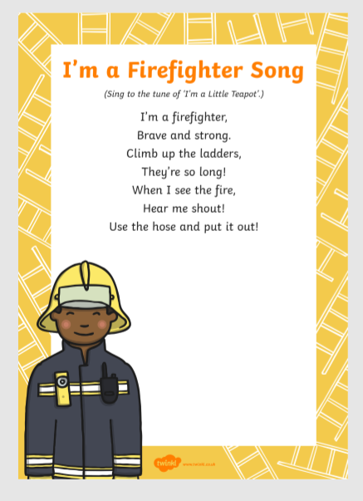

Reading:
Non-fiction reader: Emergency Services
This reader is a non-fiction text. It aims to develop both reading skills and speaking and listening skills. Each page contains a sentence for the children to read. Through a sharing of the reader you can help your child build important literacy skills. Allow your child to read the book at their own pace, there is no rush. If your child is having any difficulty with reading, please let me know and I will advise on how to help.

Genre Story: Who Will Save the Day?
(Gill Explore: Click on Unit 8-Genre Story eBooks)

The Genre Stories provide a shared reading experience with parents. Each story has a dual text, an adult text that can be listened to using the audio function or read aloud by the parent and a simplified child’s text that the child can join in with reading some of the words.

There is a work card available online to accompany the reader-see Literacy Station downloadable material for Unit 8.

Listen to the read-aloud of the story online.
Talk about the character and setting in the story.

Writing:
Write a few sentences about the topic of Firefighters.
Talk, draw and write about the topic in your copy.

***N.B. A sentence or two is plenty. Some children may be able for more, but writing at this stage should be slow and steady, so don’t spend too long at one sitting, just a few minutes. Some children may need you to write it for them on the top line and they will copy it underneath. That is fine. Every child will be different. Give them plenty of help with spelling and get them to try to sound out simple words if they can. Even if they can only come up with the initial letter of the word, that’s still a good start. Afterwards, get them to share their work with others, either in your house or your extended family on video calls, and read aloud what they wrote. Lots of praise will help them develop a sense of pride and boost their confidence with writing (and hopefully motivate them to write more).

Additional ideas/extension activities:
My News/Diary: Writing simple personal ‘news’ is useful for helping practice handwriting, basic sight words spelling, and conventions of writing such as sentence structure and grammar. Capital letters and full stops are what we concentrate on in Junior Infants, as well as sizing of the letters and using ‘finger spaces’ between words.
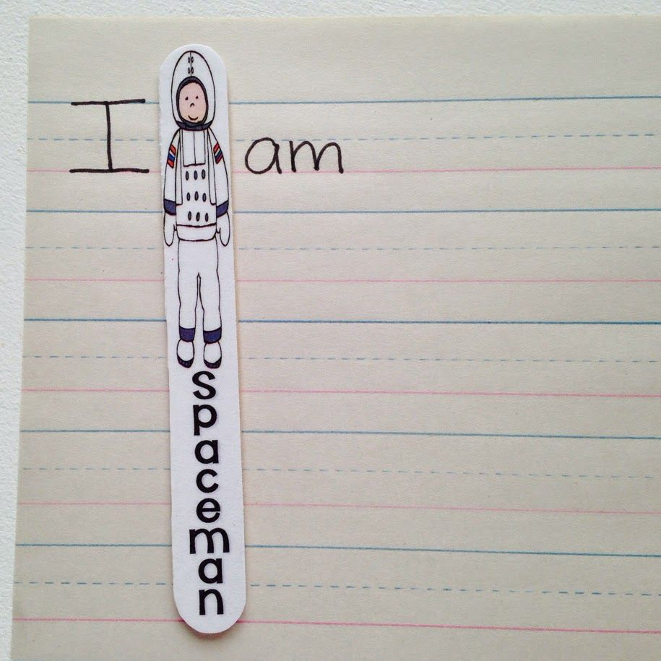
Tip: Use a lollipop stick or similar sized piece of card ‘Spaceman’ as a spacer between words can help children with this concept. Your child could decorate it themselves.

Phonics and Sight Words:
‘Op’ words: Revision of the ‘op’ family of words. See if your child can list any words ending in ‘op’, eg. Top, mop, shop, pop, flop, stop, drop, hop, etc.

See if they can write out the list of words after they have said them orally. Can they spot the pattern? (ending with ‘_op’) Can they sound them out and spell them by themselves?

It’s very important for them to keep revising their sounds, to practice blending the letters to make words-eg- “c-a-t” says “cat” and practice the sight words which Ms. O’Toole sent home.

I will pop lots of links to free Literacy resources on the website later in the week if they prefer to use online activities to motivate learning.

Aistear Ideas:
Our Aistear theme for the fortnight would have been ‘The Fire Station’. If you’d like to, here are some ideas for at home:
Socio-dramatic play:
- Set up a fire station using chairs, desk and plastic food for the canteen area
- Cushions and blankets for sleeping area
- Fire engine could be made from a cardboard box
- Phone to answer emergency calls
- Firefighter hat or costume if you already have one at home
- Buckets or water spray bottle to use as fire extinguisher, rope to use as a hose
Role-play scenarios:
- Eating in the canteen
- Making/Answering an emergency call
- Getting ready for an emergency
- Sleeping in the sleeping area
- Fighting a fire
- Rescuing an animal in distress

Construction/Junk art/Sensory Play:
- Design then build a fire station from lego or small blocks
- Use various junk materials to make a fire engine, eg, shoe boxes, yoghurt pots, glue, Sellotape, scissors, paintbrushes, paint. Or they could make a fire extinguisher from an empty lemonade bottle.
- Water play: Car wash for emergency vehicles-use toy vehicles, washing up liquid, scrubbing brushes, nail brush, old toothbrush, sponges, etc.
- Foam tray: Firefighting foam (shaving foam)-hide objects in it and children use their sense of touch to figure out what each item is.

Small World: If you have some toy emergency vehicles, you could make a street map on an old flattened out cardboard box or large sheet of paper. The children could also build lego houses on the streets and create traffic lights, street lamps, shops, etc.

Maths
The Story of Zero

Busy at Maths materials online at mycjfallon.ie,

Busy at Maths Pupils’ Textbook: pages 99, 100, 101, 102.

Home School Links Book: page 29

Online Activity Links (optional)
Page 99: http://data.cjfallon.ie/resources/19596/activity-99/index.html
Page 100: http://data.cjfallon.ie/resources/19596/activity-100/index.html
Page 101: http://data.cjfallon.ie/resources/19596/activity-101/index.html
Page 102: http://data.cjfallon.ie/resources/19596/activity-102/index.html

Mathematical language: Start at the dot, go around, down and around againg, zero, one, two, three, four, five, how many?, set, more, ring, trace, colour, write, count.

The Home School Links page for this topic is attached below:
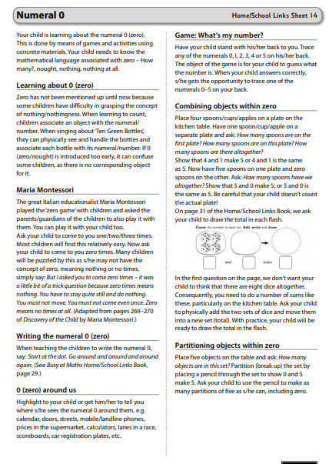

Gaeilge
If you don’t feel confident with Gaeilge, don’t worry. There is a free app called DuoLingo which is quite simple and pupils seem to enjoy it. This might be an option. If you do want to attempt it, I’ve translated this week’s story and tasks below. Abair Liom B has some nice songs and rhymes online also.

Abair Liom B

All resources for the Abair Liom Programme are available free on www.folensonline.ie . To set up an account, follow the steps below:
- Go to Folensonline.ie and click Register
- Select Teacher
- Fill in a username, email and password
- When asked for Roll Number, use the code: Prim20
- Type ‘Abair Liom B’ into search bar.
- Under the image of ‘Abair Liom Senior Infants’, click on ‘Resources’
- Under ‘Lesson’, click on ‘24 Hansel agus Gretel’
- On the ‘Scéal’ box, click Open
- Play and listen to the story. (Translation below)
- There are also digital ‘Luaschártaí’ (Flashcards) based on some vocab from the story which you could use if you wish.

Abair Liom B pupil’s textbook: Pages 84 & 85 (Junior Infants will need a good bit of help with this-just try your best)

Pictiúr 1:  Hansel agus Gretel  Fadó fadó, bhí buachaill beag agus cailín beag ann. Hansel agus Gretel ab ainm dóibh. Chonaic said teach álainn sa choill. As seacláid, brioscaí líreacháin agus milseáin a bhí an teach déanta. Rith said go dtí an teach.  Hansel: Ó is breá liom an teach seo!  Gretel: Is féidir é a ithe. | Picture 1:  Hansel and Gretel  Long ago, there was a little boy and a little girl. Hansel and Gretel were their names. They saw a lovely house in the woods. It was made from chocolate, biscuits, lollipops and sweets. They ran to the house.  Hansel: Oh I love this house!  Gretel: It can be eaten.
Pictiúr 2:  An Chailleach Ghránna: Fáilte romhaibh, a pháistí. Tagaigí isteach, tagaigí isteach. (ag gáire) Seo líreacháin duit! Seo léreacháin duit! | Picture 2:  The Ugly Witch: Welcome, children. Come in , come in. (laughing) Here is a lollipop for you! Here is a lollipop for you!
Pictiúr 3:  An Scéalaí: Thug an Chailleach Ghránna go leor brioscaí agus milseáin do Hansel agus Gretel.  Gretel: Go raibh maith agat.  Hansel: Go raibh míle maith agat. | Picture 3:  Narrator: The Ugly Witch gave Hansel and Gretel lots of biscuits and sweets.  Gretel: Thank you  Hansel: Thank you very much
Pictiúr 4:  An Scéalaí: Ansin chaith an Chailleach Ghránna Hansel bocht isteach i gcás. Thosaigh sé ag caoineadh. Hansel: Lig amach mé! Lig amach mé!  An Scéalaí: Thosaigh Gretel ag caoineadh freisin.  Gretel: Tá eagla orm. Ba mhaith liom dul abhaile. | Picture 4:  Narrator: Then the witch threw poor Hansel into a cage. He started crying. Hansel: Let me out! Let me out!  Narrator: Gretel started crying also.  Gretel: I’m scared. I’d like to go home.
Pictiúr 5:  Bhí an Chailleach Ghránna chun Hansel a ithe.  An Chailleach Ghránna: Mmmm! Mmmmm!  Hansel: Lig amach mé! Lig amach mé!  An Scéalaí: Go tobann, thit an Chailleach Ghránna isteach sa tine. B’in deireadh leis an gCailleach. | Pictiúr 5:  The Ugly Witch was going to eat Hansel.  The Ugly Witch: Mmmm! Mmm!  Hansel: Let me out! Let me out!  Narrator: Suddenly, the Ugly Witch fell into the fire. That was the end of the witch.
Pictiúr 6:  An Scéalaí: Bhí Hansel agus Gretel sásta ansin. Bhí go leor milseáin acu. Hansel: Ium ium ium!  Gretel: Is maith liom an teach seo.  An Scéalaí: Ansin, chuaigh Hansel agus Gretel abhaile. | Picture 6:  Narrator: Hansel and Gretel were happy then. They had a lot of sweets. Hansel: Yum yum yum!  Gretel: I like this house.  Narrator: Then, Hansel and Gretel went home.

Page 85:
Tasc A  Féach ar an teach. As seacláid, broiscaí, líreacháin agus milseáin atá an teach déanta. Tarraing Hansel agus Gretel ina seasamh sa gháirdín. Tarraing an Chailleach in aice leis an teach. Tarraing trí líreacháin sa gháirdín. Tarraing cúig mhilseáin sa gháirdín freisin. Tarraing ceithre chrann sa choill. | Task A  Look at the house. It’s made from chocolate, biscuits, lollipops and sweets. Draw Hansel and Gretel standing in the garden. Draw the witch beside the house. Draw three lollipops in the garden. Draw five sweets in the garden also. Draw four trees in the woods.
Tasc B  Cuir méar ar Hansel. Dathaigh a léine glas agus a bhriste buí. Cuir méar ar Gretel. Dathaigh a t-léine gorm agus a sciorta oráiste. Cuir méar ar an Cailleach. Dathaigh an Cailleach dubh. Anois, dathaigh na milseáin go léir dearg. | Task B  Put your finger on Hansel. Colour his shirt green and his trousers yellow. Put your finger on Gretel. Colour her t-shirt blue and her skirt orange. Put your finger on the Witch. Colour her black. Now, colour all the sweets red.

