Good morning boys and girls.
I hope you enjoyed your fun Active School’s Week at home last week. Below are the activities for the remainder of term. There are some work activities and some fun activities as we finish off for the term. Enjoy.
Mrs. O’Sullivan
Maths: Finish off the last two chapters in your Mental Maths Book.
Tables: Watch the Tables card game and play with your family every day.
https://www.youtube.com/watch?v=R5E_33YyGN0
ACTIVITY : Why not try out the Noggle worksheets attached and see how you get on.
Spellings: Complete Unit 18 in your Spelling Book.
Writing: There are two writing activities upload – Character description and a healthy food persuasive template - Use your great literacy skills to complete these.
Oral Language Games:
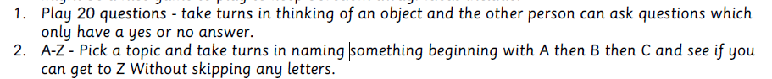
ART:
- Drawing: Will Sliney, the fantastic MARVEL comic book animator has some fantastic online videos of some superheroes Spiderman, Starwars and Pokeman. Check out his videos on You Tube Will Sliney We will draw. Why not become an animator now and try out some of his techniques and drawings
- Collage. Why not draw a big ice cream cone on a sheet of paper. Collect old magazines or papers and tear out different colours pieces (about 2 to 3 cm in size). Now decorate your cone to any flavour you would like.
BBC Dance Mat. If you have a laptop, why not learn to type. This is a fun website and teaches you how to type. Typing is a great skill to learn now and whenever you pick up the laptop you can practice this great skill.
P.E: Return to the activities for ACTIVE SCHOOLS WEEK and choose one to do each day. Enjoy.

