Senior Infants Work-Week beginning Monday 27th April
Hi everyone, I hope last week went well. Thanks for the lovely photographs, I am so impressed at all the great work produced, well done! Don’t forget to take plenty of breaks and play outside lots, if the weather allows! I’ve attached this week’s work below, but again, only do what you are able for and don’t stress about what you don’t get done. Also, if you don’t have access to the internet, you can still work on the workbook pages, your non-fiction and fiction readers, and work on lots and lots of practicing of your sight words and sounds. And don’t forget to Read, Read, Read!!! Paired Reading with a parent is a very effective way at increasing reading enjoyment and motivation. Bedtime stories are a fantastic way to incorporate Paired Reading into daily life.
I am on a teacher training course via Zoom today, Monday 27th and tomorrow, Tuesday 28th so there may be a delay in responding to emails on those days, but I will get back to you as soon as I can.
Please pick and choose from the below activities and ONLY DO WHAT SUITS YOUR FAMILY, don’t feel that you have to do it all, and remember, TAKE LOTS OF BREAKS to avoid frustration and increase motivation.
Work for week beginning Monday 27th March
English-Over the Moon Unit 8  Reader: The Zoo  Report Writing  Poem: The Zoo  Oral Language: Following auditory directions Skills Book p  Phonics: Revise or, ar, er,ir, ur. | Maths-Combining and partitioning withing five including zero  Busy at Maths pgs.  Home-School Links pages | Gaeilge: Abair Liom B Súil Siar 4, pgs. 86&87
Handwriting: Choose an activity from the Letter Formation and Writing Activities on the class page on school website | PE:Choose from the list of ‘PE At Home’ activities on the class page on school website. The ‘Indoor PE and movement breaks’ section might be needed if the rain keeps up! | Fine Motor: Some fine motor skills activities from the list on the class page of school website
For art, music, science, I will upload ideas to the school website throughout the week. I will also upload a themed powerpoint of activity ideas, this week’s theme is Being Active/Sports/Football. This can be used as alternative learning ideas. If you have any ideas for future powerpoint activities that would interest your child, please let me know. As always, just do what you can!
Below I have explained how to go about doing the above work with your child. However, this is just a guide, if you wish to go about it a different way, please do. This is just to help anyone who would like it. If you can email on 3 photos by Friday evening I’d really appreciate it, if this is not possible, don’t worry.
Senior Infants Week beginning Monday 27th April
English Literacy: Over the Moon Programme

Unit 08
Theme: The Zoo
Oral Language:
To access interactive activities and oral language poster, go to https://www.gillexplore.ie/gill-explore-resources/over-the-moon-senior-infants-skills-book

Then under All Chapters, scroll down and click Unit 08 and under All Recource Types, scroll down and click Oral Language & Interactive Activities, then Oral Language Poster, then Explore Mode.

These oral language activities involve discussing the digital poster ‘The Zoo’ on Gill Explore. The activities may be used as preparatory work for the corresponding activity page in the children’s skills book which they will be working on next week.

- So much of the Junior and Senior Infants Curriculum is based on oral language, so also keep up plenty of chatting and look for new words and vocabulary.

Poster 08-The Zoo
Looking at the poster from last week, this time we are going back into Oral Language and Interactive Resources to look at it using Story Mode. Listen to the story and answer the question at the end of the story.

Skills Book Page 102-A Busy Day at the Zoo
Barrier game-can be played by taking turns, allowing the adult giving the child instructions on what to colour in the picture, then the child giving an instruction to the adult to colour in a section, an so on. Example, ‘Colour the camel yellow. Colour the seal grey.’
Think, Pair, Share.

Reading: (Continue with reader from last week)
Non-fiction reader: The Zookeeper
This reader is a non-fiction text. It aims to develop both reading skills and speaking and listening skills. Each page contains a sentence for the children to read. Through a sharing of the reader you can help your child build important literacy skills. Allow your child to read the book at their own pace, there is no rush. If your child is having any with reading, please let me know and I will advise on how to help.

Genre Story: Life in the Zoo
This is a shared reader-for parent to read to/with child.
Click on Unit 08, Genre Story e-books, or try this link:
https://www.gillexplore.ie/gill-explore-resources/over-the-moon-senior-infants-skills-book?Chapters=7661&ResourceTypes=11314

After reading comprehension (Pause after each page section and answer the questions):
(Oral language)
Pages 2-3: Why do you thing Robbie wants to be a zookeeper?
Who do you think lives in the president’s house?
Pages 4-5: Why do you think the flamingo has a long neck?
Pages 6-7: Whey do you think Mr. Lillis has a red face?
What is the zookeeper doing?
Pages 8-9: Why do you think hippos love water?
Pages 10-11:Why do you think the peacock is on the trailer?
Pages 12-13: Why do you think lions hunt at night?
Pages 14-16Would you like to be a zookeeper?

Text detective: Recall from the text-What park is the zoo in?
What character in the story wants to be a zookeeper?
What do you call a flock of flamingos?
Can you name a dangerous animal?
Why was the zookeeper driving a trailer full of meat?
Where do lions like to live?

Writing:
Report writing: (Skills Book page 104) A-Match each fact about the lion to the correct box to complete the report. B-Write one fact about the lion. C-Give an oral report about the lion to your parent.

Additional ideas/extension activities:
My News/Diary: Writing simple personal ‘news’ is useful for helping practice handwriting, basic sight words spelling, and conventions of writing such as sentence structure and grammar. Capital letters and full stops are what we concentrate on in Junior Infants, as well as sizing of the letters and using ‘finger spaces’ between words.
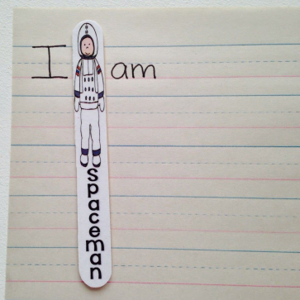
Tip: Use a lollipop stick or similar sized piece of card ‘Spaceman’ as a spacer between words can help children with this concept. Your child could decorate it themselves.

Grammar:
Capital Letters and full stops
Skills Book page 112.

Phonics and Phonological Awareness:
- Skills Book page 103: Medial Sounds

- Syllable Sort
Downloadable materials for Unit 8:
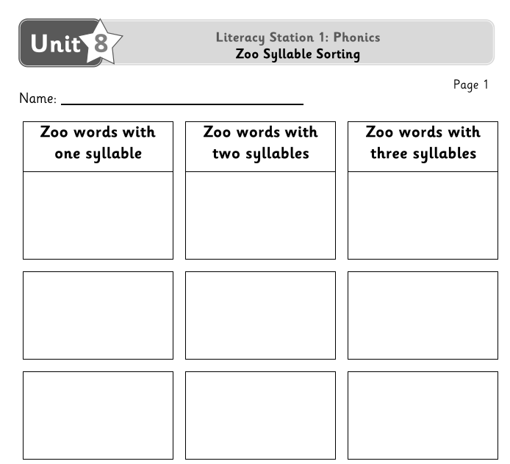

It’s very important for them to keep revising sounds, to practice blending the letters to make words-eg- “c-a-t” says “cat” and practice the sight words and sounds mat which Ms. O’Toole sent home.

Aistear: (same as last week)
Maths
Is more than…./is less than…

Busy at Maths materials online at mycjfallon.ie

Busy at Maths Pupils’ Textbook: pages 102, 103

Home School Links Book: page 35

Master your Maths book: Start new week Mon-Thursday and corresponding end of week Test. Don’t forget to time yourself and record your time each day to see if you are getting faster!

Online Activity Links (optional)
Page 102
http://data.cjfallon.ie/resources/19602/activity-102/index.html
Page 103 http://data.cjfallon.ie/resources/19602/activity-103/index.html

Mathematical language: How many? Count, is more than, is less than, has more, has less, nearly as many, count on, look closely, which set has more/less, blue, green, yellow.

The Home School Links page for this topic is attached below or can be accessed athttps://my.cjfallon.ie/ebooks/19640-PCMs103-123.pdf
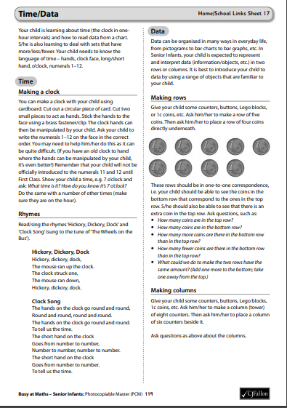

Gaeilge
If you don’t feel confident with Gaeilge, don’t worry. There is a free app called DuoLingo which is quite simple and pupils seem to enjoy it. This might be an option. If you do want to attempt it, I’ve translated this week’s story and tasks below. Abair Liom B has some nice songs and rhymes online also.

Aonad 19: Suil Siar. This chapter is a revision of work done in lessons 19 -23.

Abair Liom B

All resources for the Abair Liom Programme are available free on www.folensonline.ie . To set up an account, follow the steps below:
- Go to Folensonline.ie and click Register
- Select Teacher
- Fill in a username, email and password
- When asked for Roll Number, use the code: Prim20
- Type ‘Abair Liom B’ into search bar.
- Under the image of ‘Abair Liom Senior Infants’, click on ‘Resources’
- Under ‘Lesson’, click on ‘Súil Siar 4’ (Looking Back 4)
- On the ‘Tráth na gCesit’ (Quiz) box, click Open
- Your child can play the quiz game by clicking on the correct picture.
- ‘Measúnú 4, téachsleabhar , lch 86’ can be used for page 86 in the textbook, or you could just read it out yourself, translation below. Make sure to pause it every time if you use the online resource as it goes too fast.

Tip-if you are unsure of the pronunciation of any of the words, www.focloir.ie is an online dictionary and you can click on the speaker icon to hear the word pronounced as Gaeilge.

Abair Liom B pupil’s textbook: Pages 86 (Junior Infants will need a good bit of help with this-just try your best)

Leathanach 86 Tasc A:
Cuir méar ar an bplúr. Anois ceangail na poncanna.
Put your finger on the flour. Now join the dots.
Cuir méar ar an gcrann. (tree) Anois ceangail na poncanna.
Cuir méar ar an bpláta. (plate) Anois ceangail na poncanna.
Cuir méar ar an tseamróg. (shamrock) Anois ceangail na poncanna.
Cuir méar ar an scamall. (cloud) Anois ceangail na poncanna.
Cuir méar ar an gciseán. (basket) Anois ceangail na poncanna.
Cuir méar ar an gcoinín. (rabbit) Anois ceangail na poncanna.
Cuir méar ar an spúnóg. (spoon) Anois ceangail na poncanna.
Cuir méar ar an gcaisleán. (castle) Anois ceangail na poncanna.
Cuir méar ar an sicín.(chicken) Anois ceangail na poncanna.
Cuir méar ar an mbratach. (flag) Anois ceangail na poncanna.
Cuir méar ar an ribín. (ribbon) Anois ceangail na poncanna.
Page 87 Task B, Cluiche Biongó

Bingo.
Call out the following words and ask the child to draw them in the spaces on the Bingo card. When they have completed the card, they shout ‘Biongó!’
Tarraing (Draw)…..
- pota óir (pot of gold)
- siúcra (sugar)
- cáca (cake)
- crann (tree)

Page 87 Task C, Colour the picture.

