Fun ways to practice your letters and writing!
Correct letter formation animations available on
https://www.gillexplore.ie/gill-explore-resources/over-the-moon-junior-infants-skills-book?Chapters=7661&ResourceTypes=11535

Blackboard and chalk. You can also go over writing with a paintbrush and water!  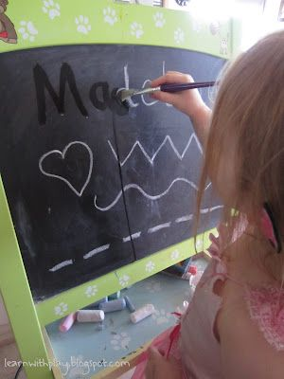 | Whiteboard and markers  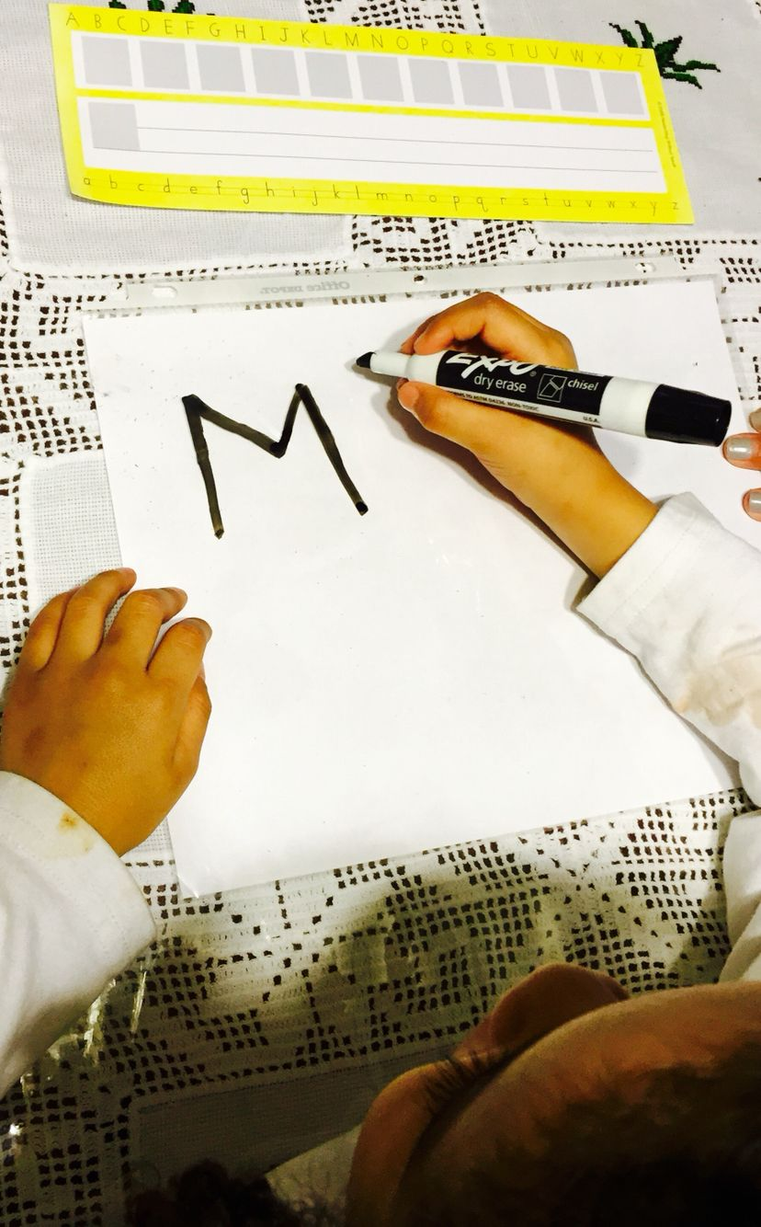
Chalk on the footpath  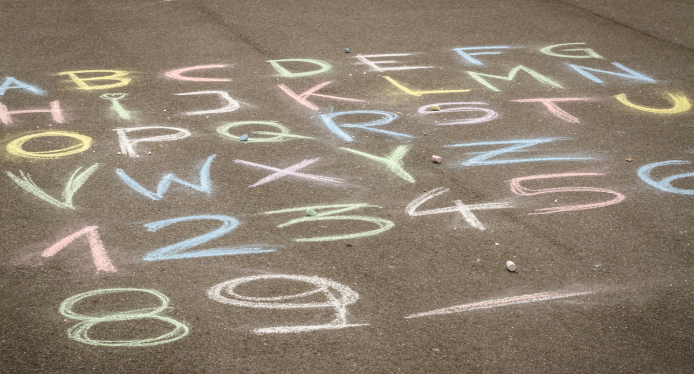 | Paint-use a cotton bud or a paintbrush  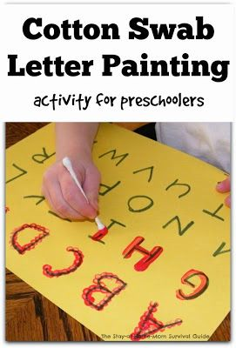  https://thestay-at-home-momsurvivalguide.com/learning-to-write-alphabet-with-cotton
sand/flour/rice in a baking tray  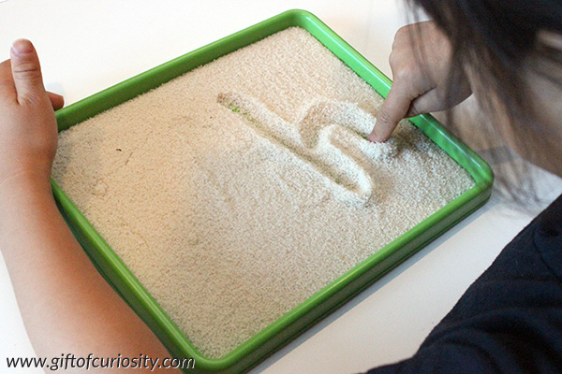 | Shaving foam  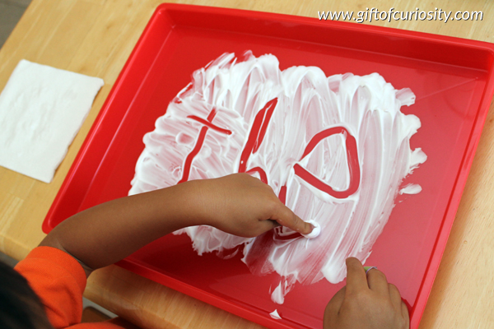
Handwriting app such as Handwriting without tears (use a stylus instead of fingers)  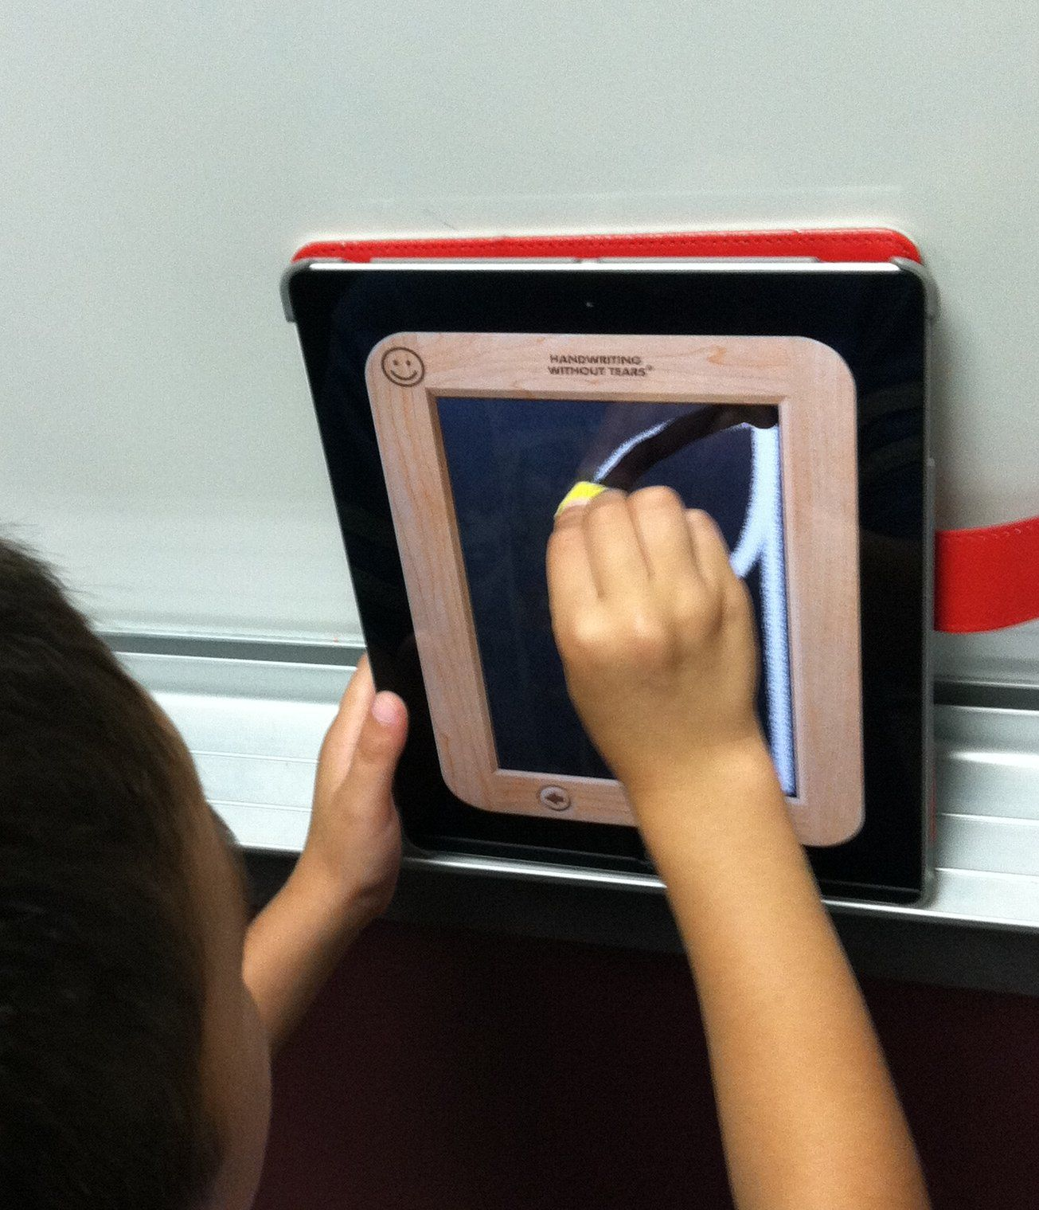 | Change up the angle-try sticking a page onto a window or write on an easel (requires muscles to work harder)  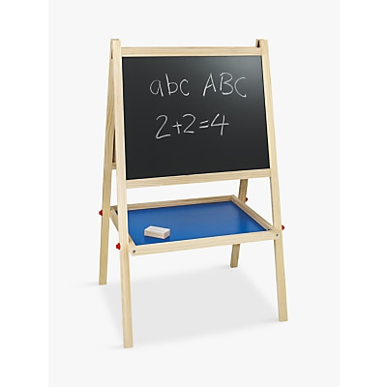
Vary your stationery-try a thin and thick pencils, crayons, markers, twistables, oil pastels, etc.  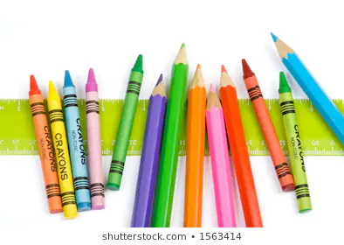 | Try different types of paper-tracing paper, tin foil, card, cardboard, etc.  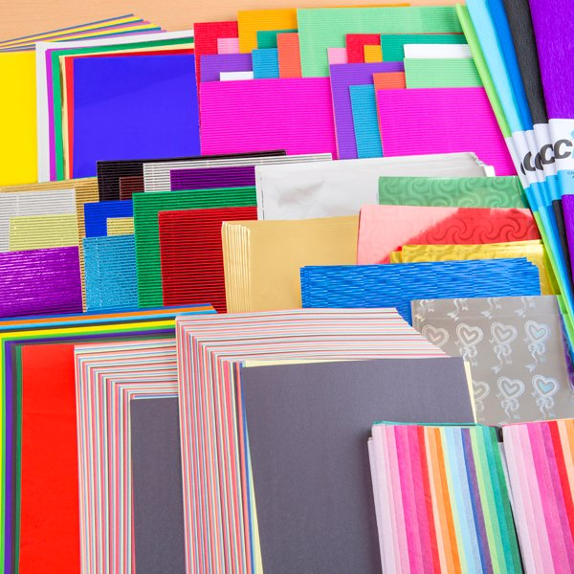
Fill a clear Ziploc bag with hair gel and watch the letters appear  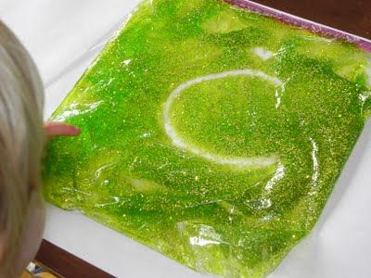 | Finger-trace letters on your parents’ backs and see if they can guess what letter it was, or trace onto letters drawn on cards!  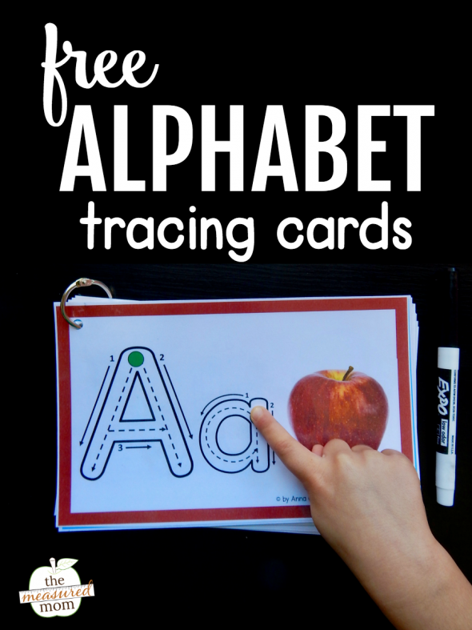  Free letter tracing cards: https://www.themeasuredmom.com/free-alphabet-tracing-book/
Bubble wrap letter pop! Draw letters in marker first then pop the bubbles the marker covers!  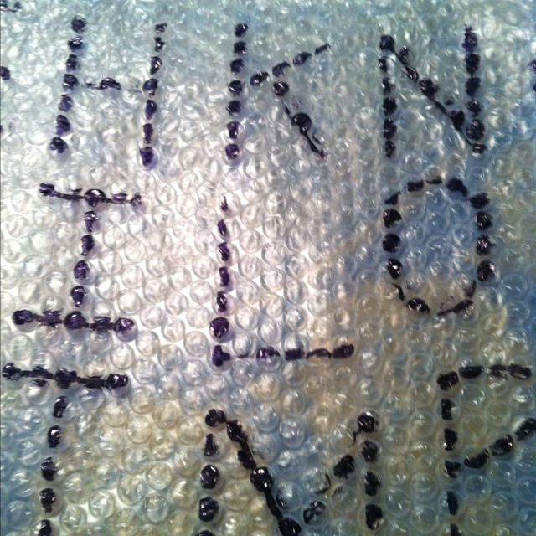 | Use bath crayons to practice writing on the bath tub!  